# **Generalization vs Specialization**

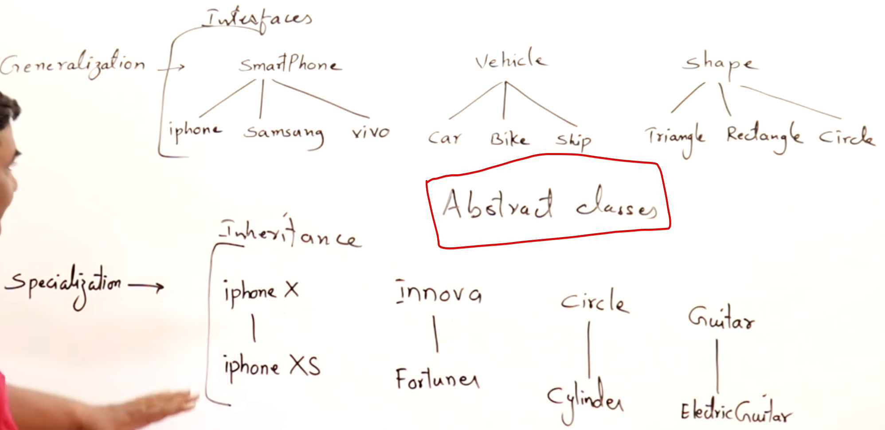

Generalization 🡪 Bottom to Top Approach  
We can group iphone, Samsung, vivo into a single group called smartphone.  
Specialization 🡪 Top to Bottom Approach  
Inova(base class) + additional features(derived class) tends to Fortuner.

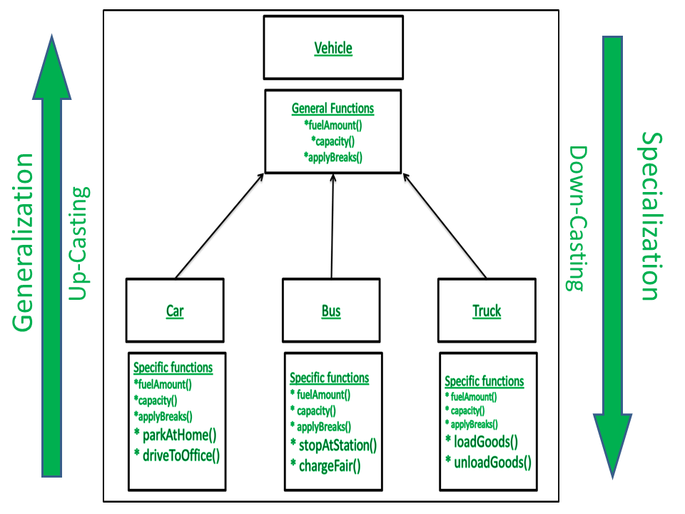

# **Inheritance**

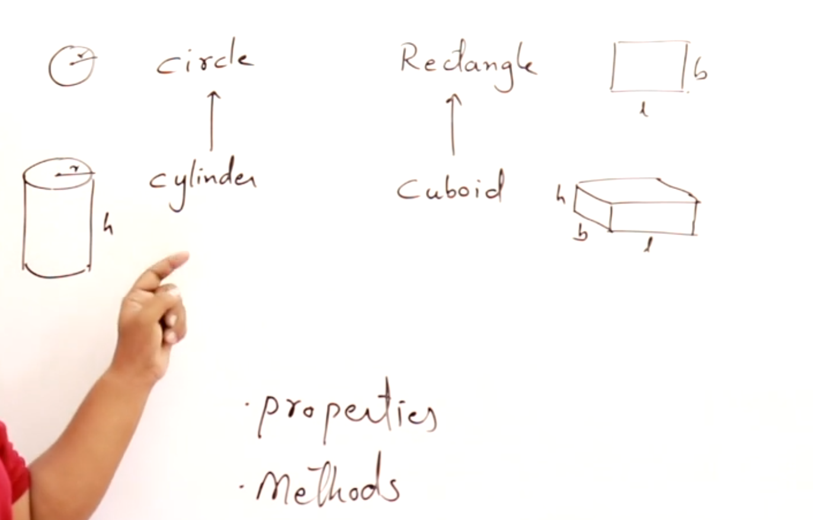

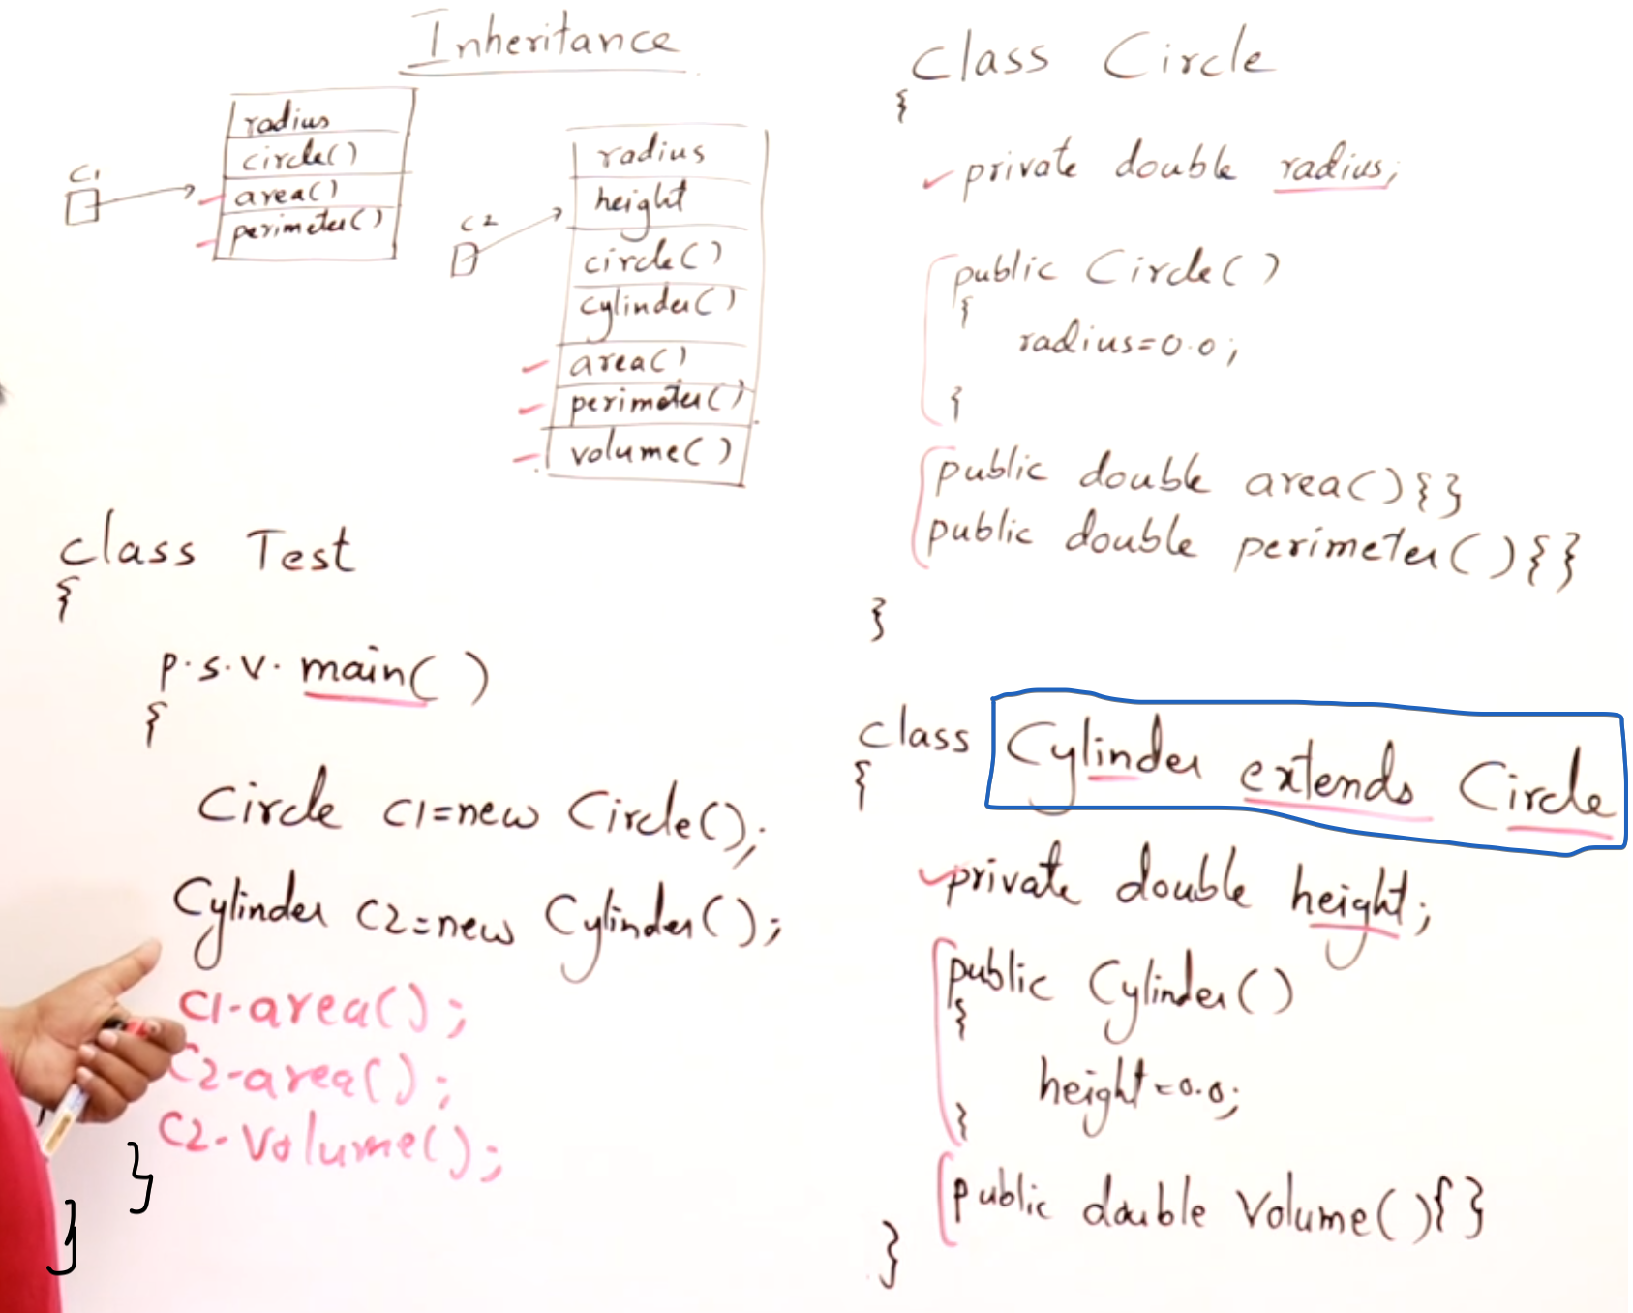

## **Refer Circle Cylinder.java**

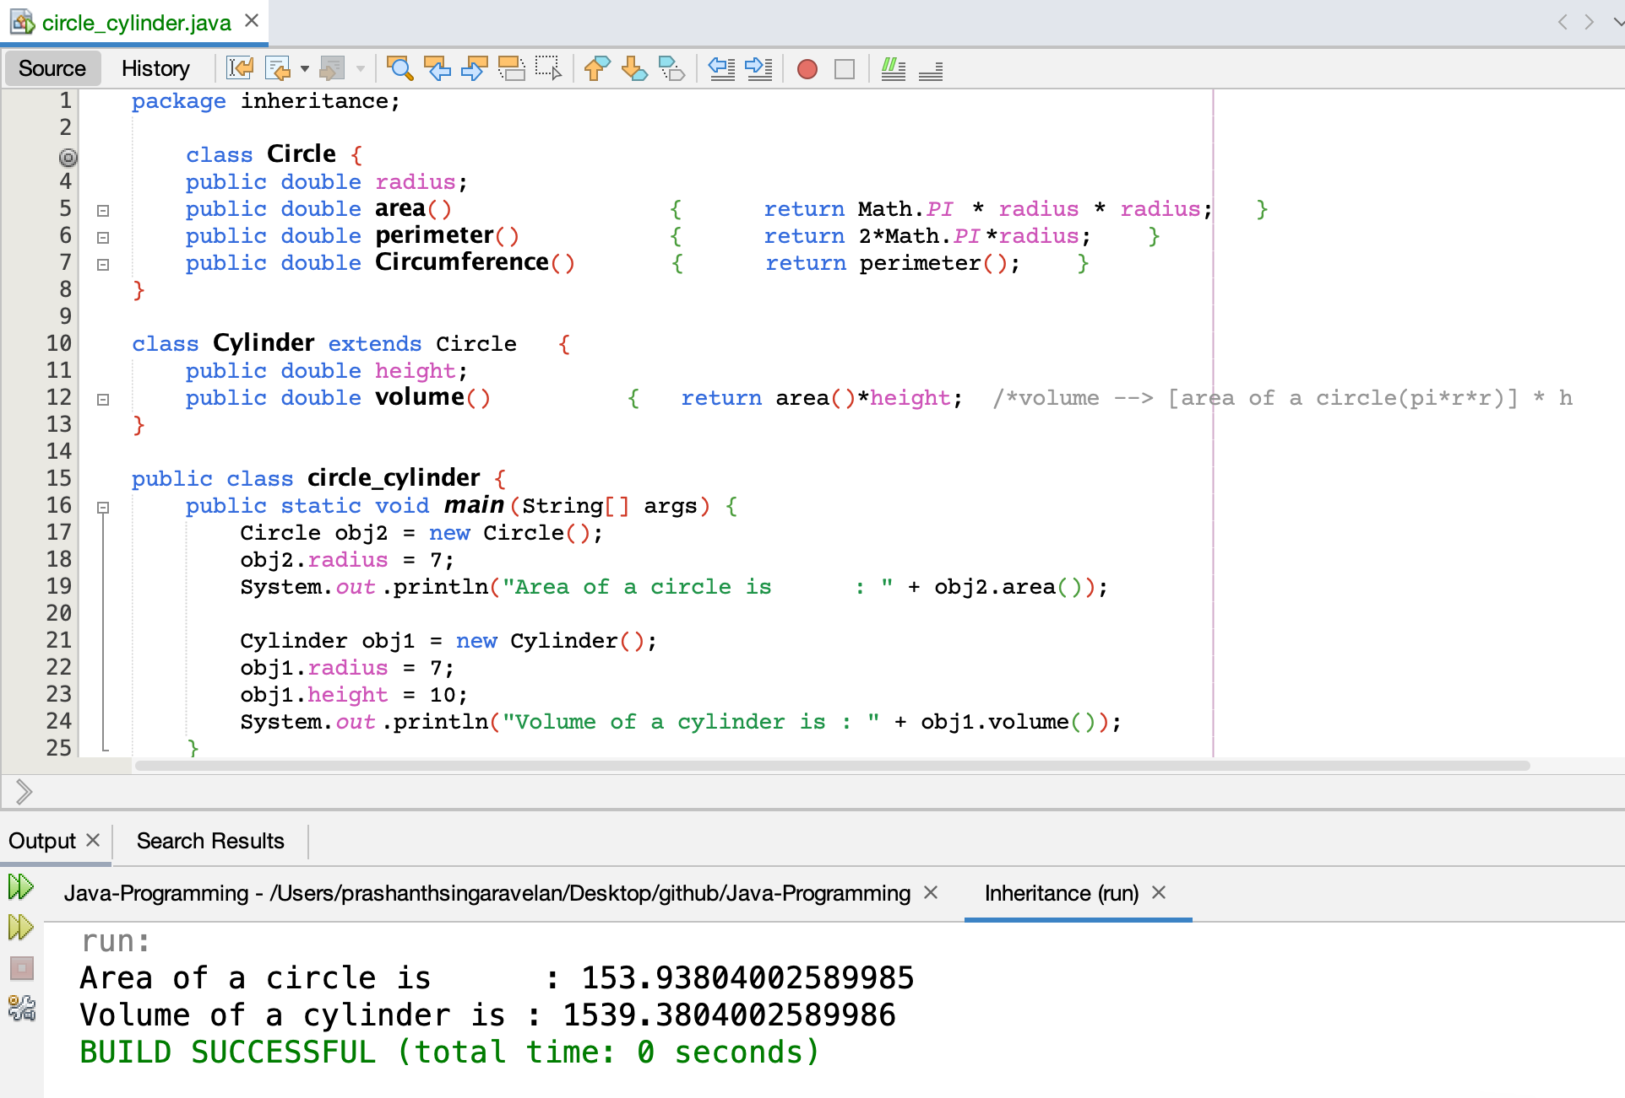

## **Account example**

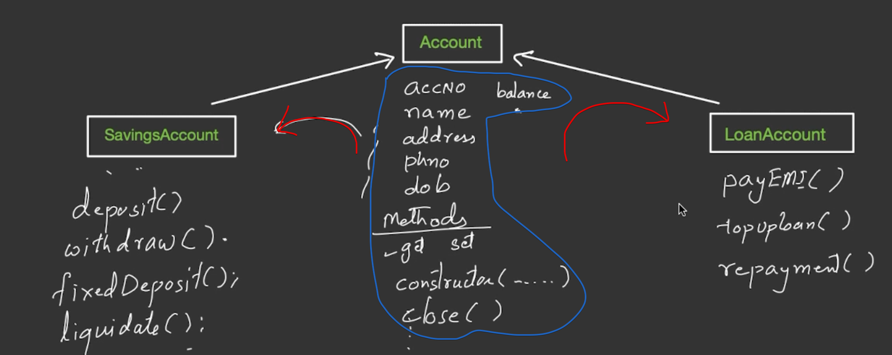

## **Cell-Phone and Customer**

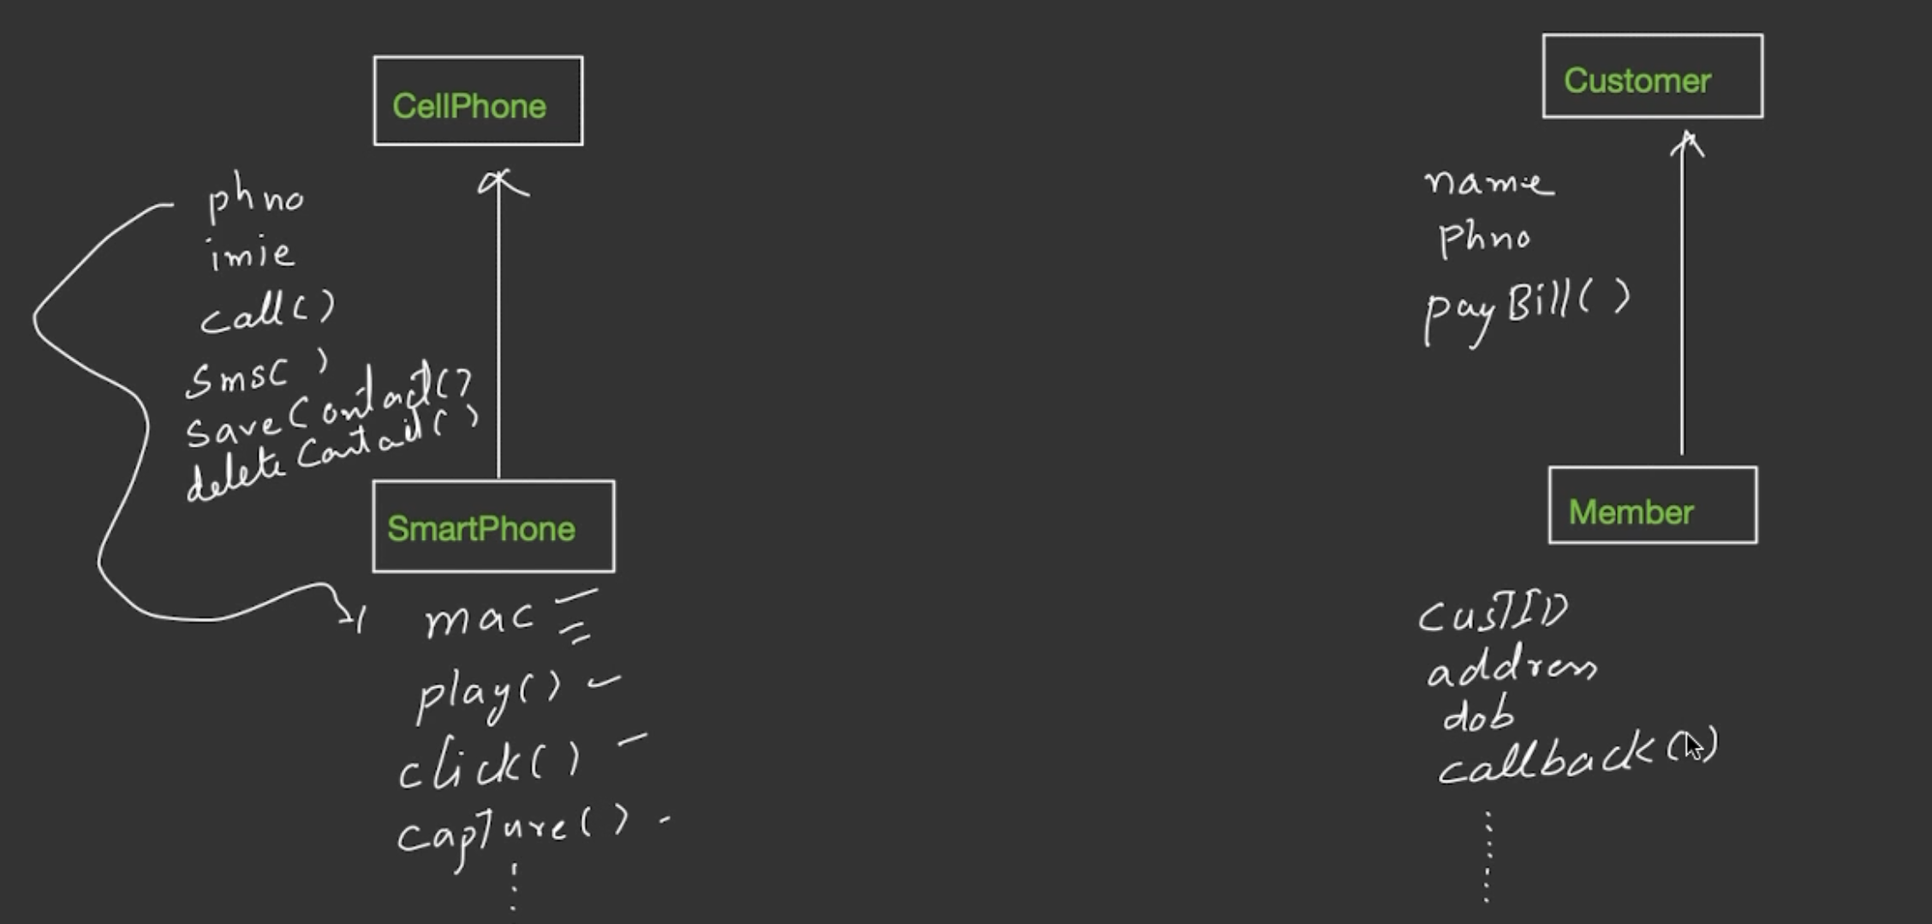

# **Constructors in Inheritance**

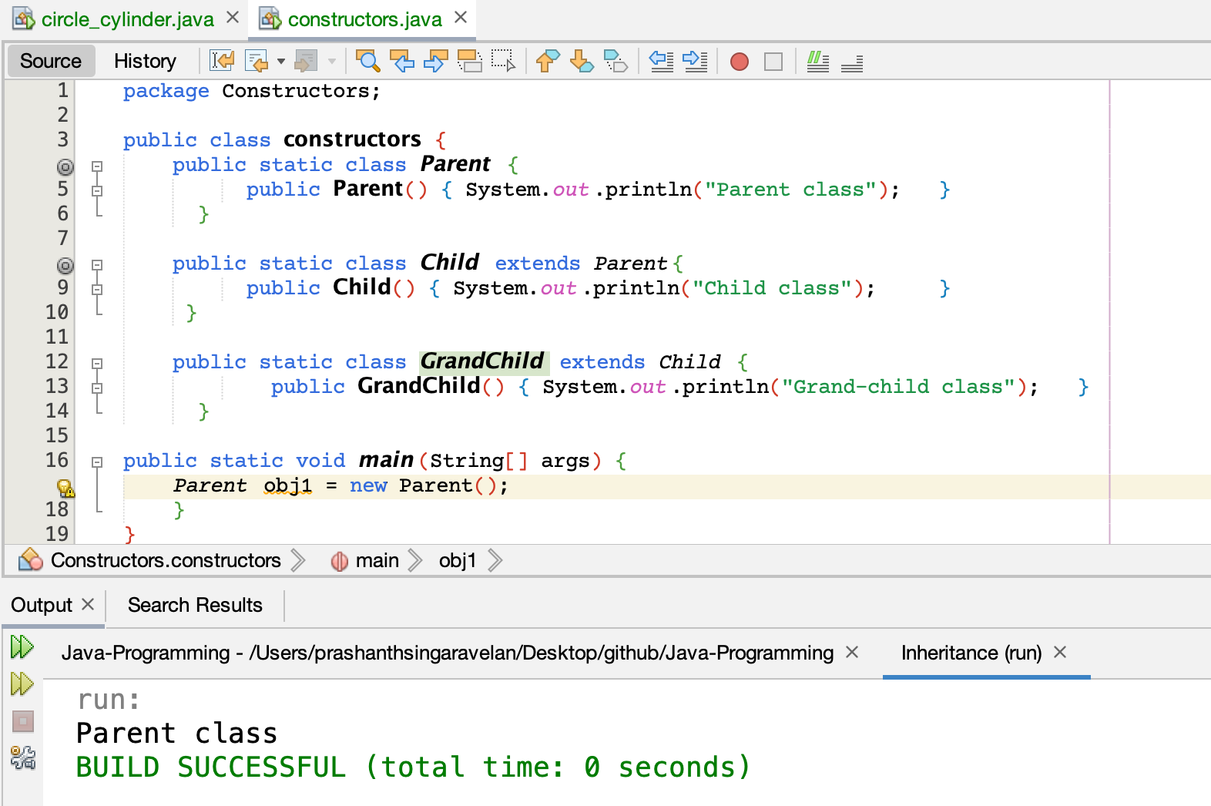

Only Parent class will be executed.

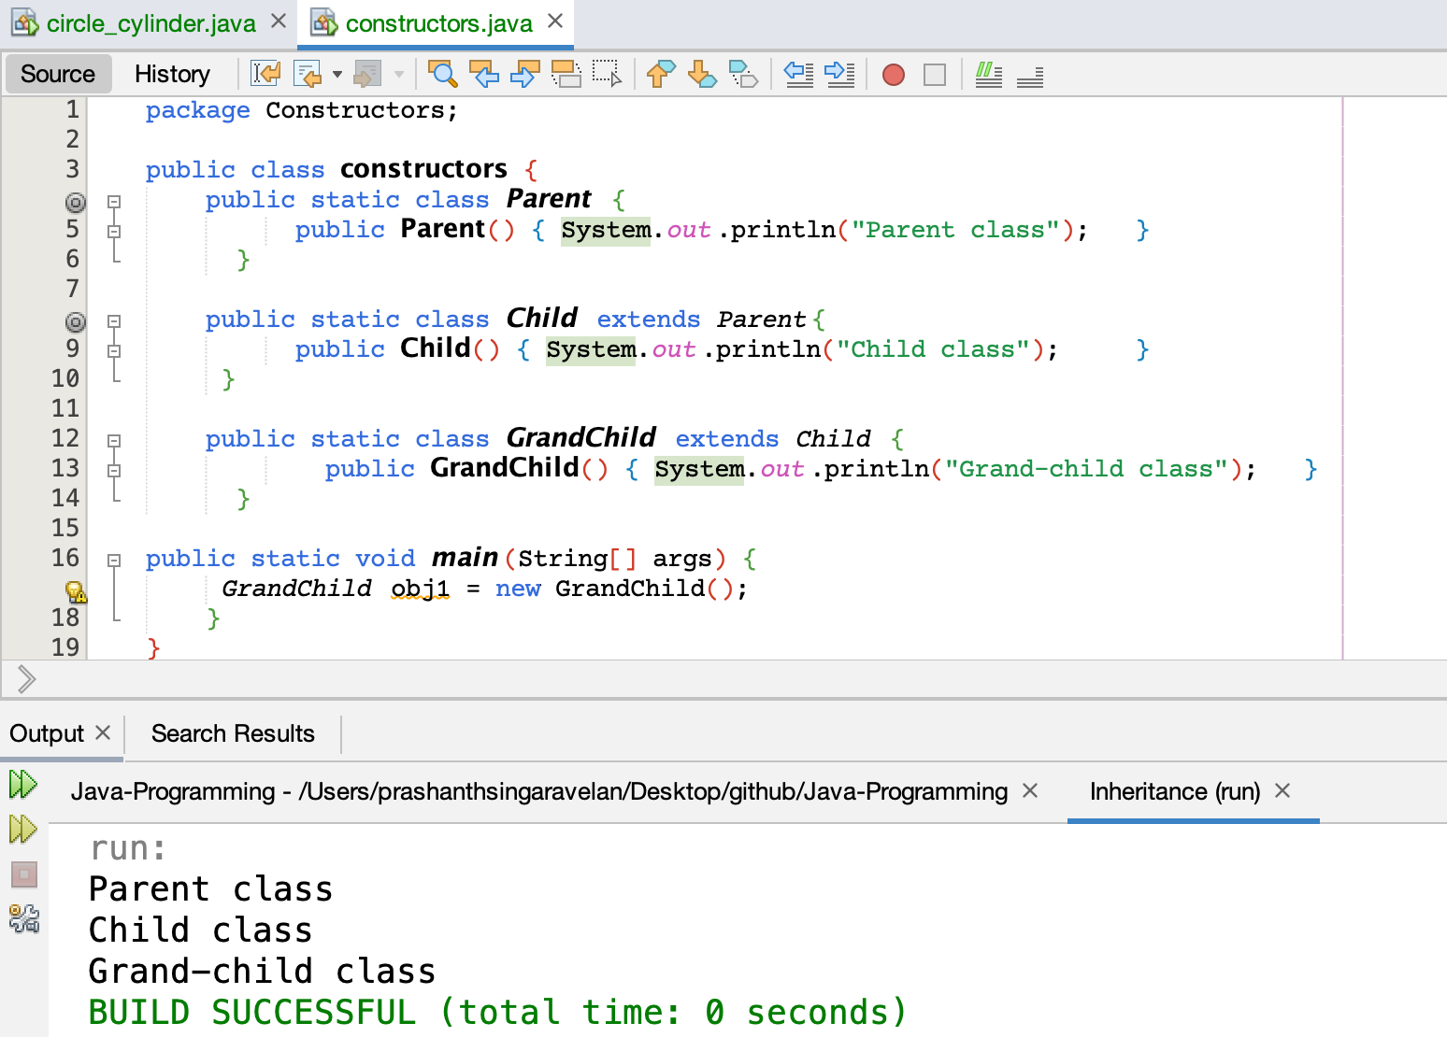

Parent, Child and Grand Child classes are executed.

Constructors are executed from top to bottom.

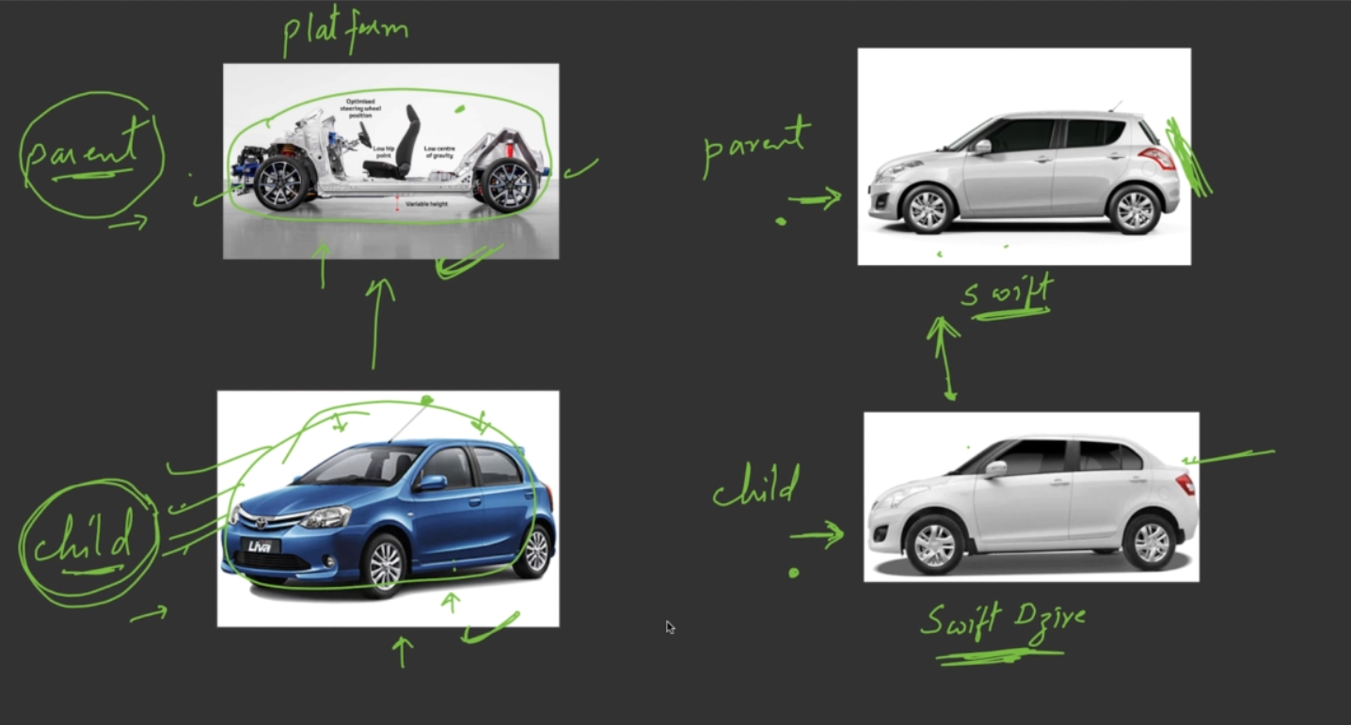

# **Parameterized Constructors**

## **parameterized_constructor.java**

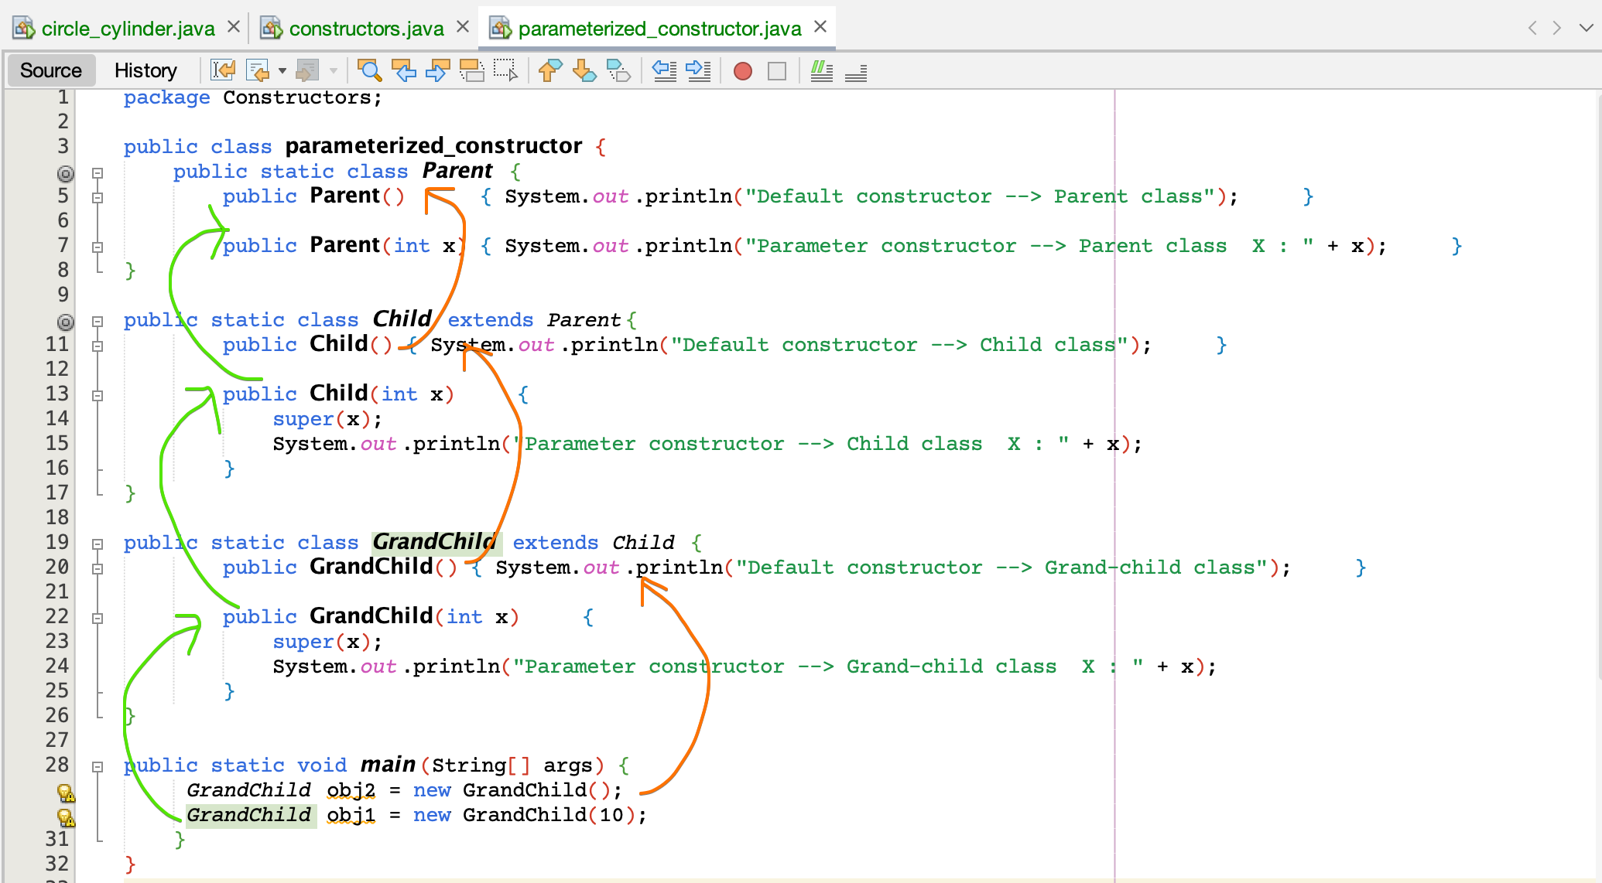

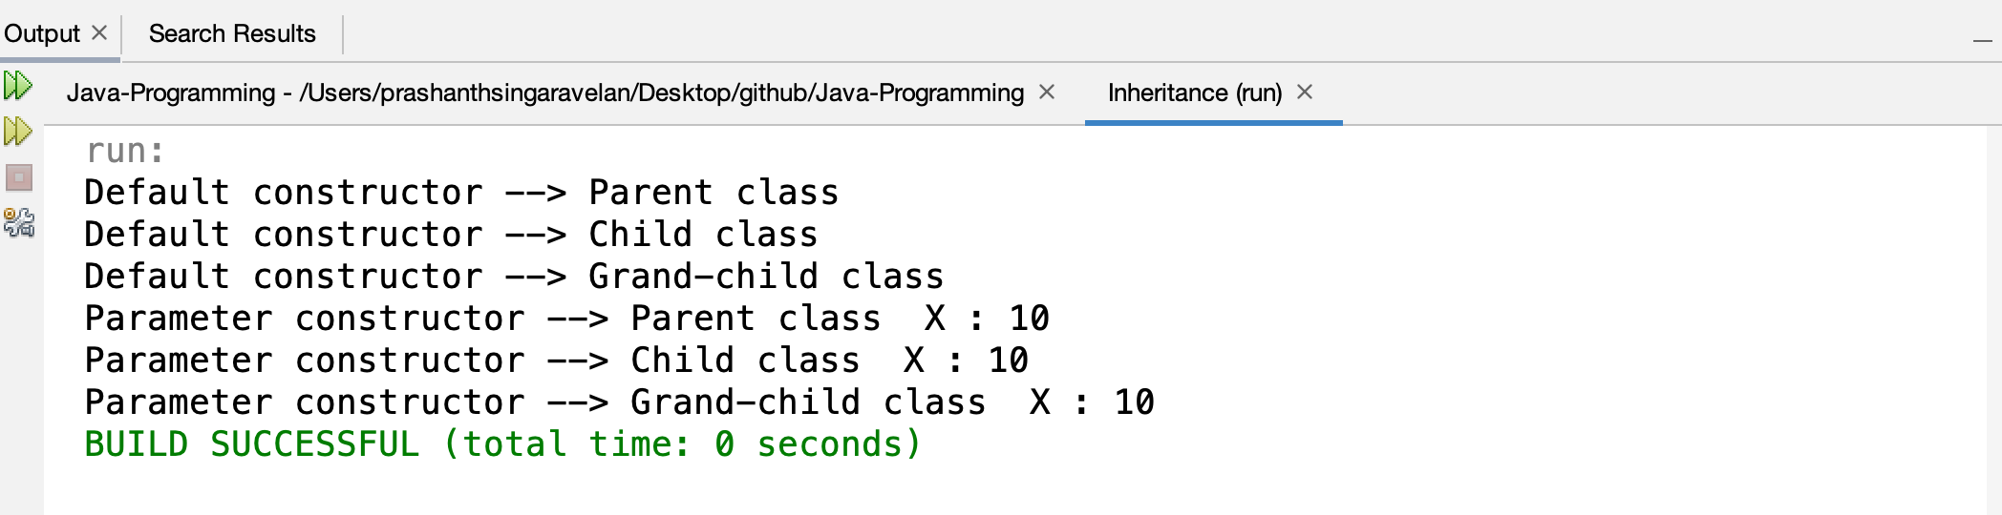

## **rectangle_cuboid.java**

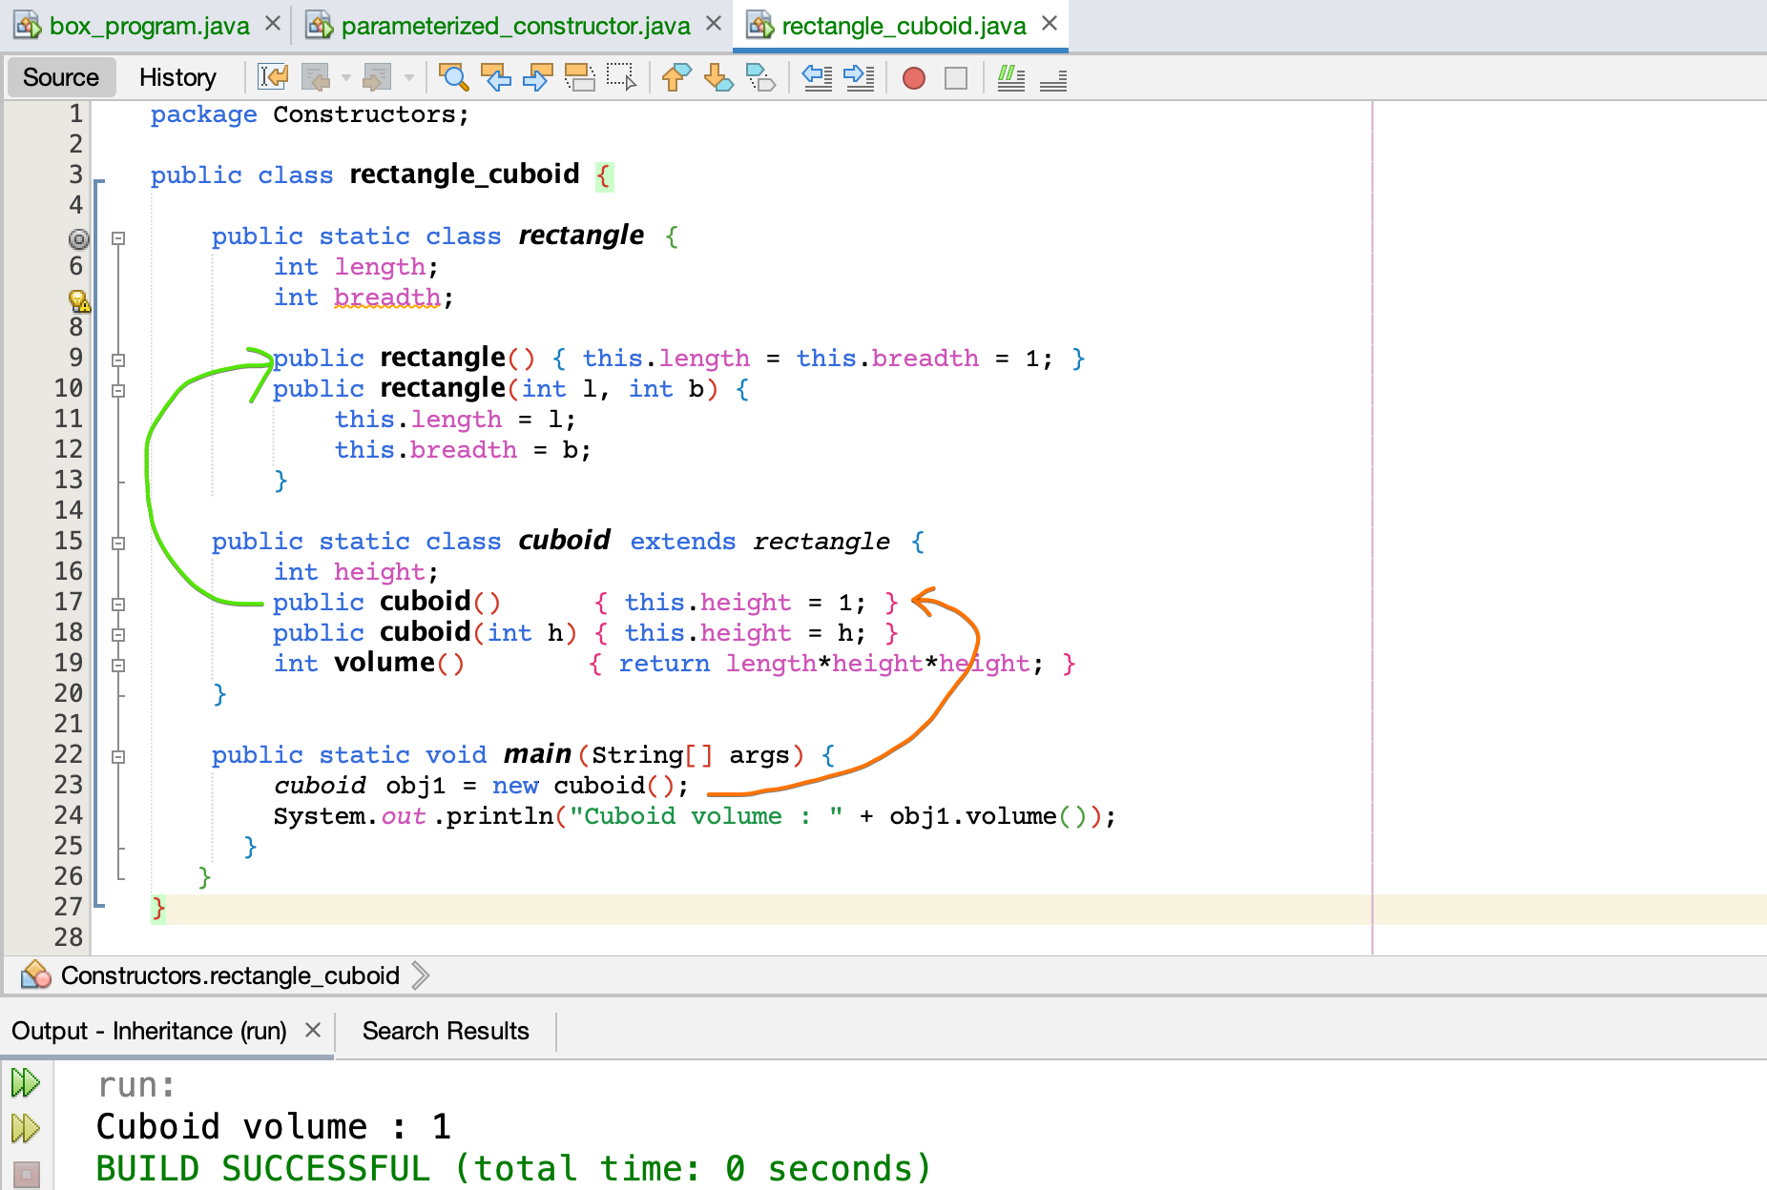

cuboid’s class and rectangle class 🡪 default constructor is called

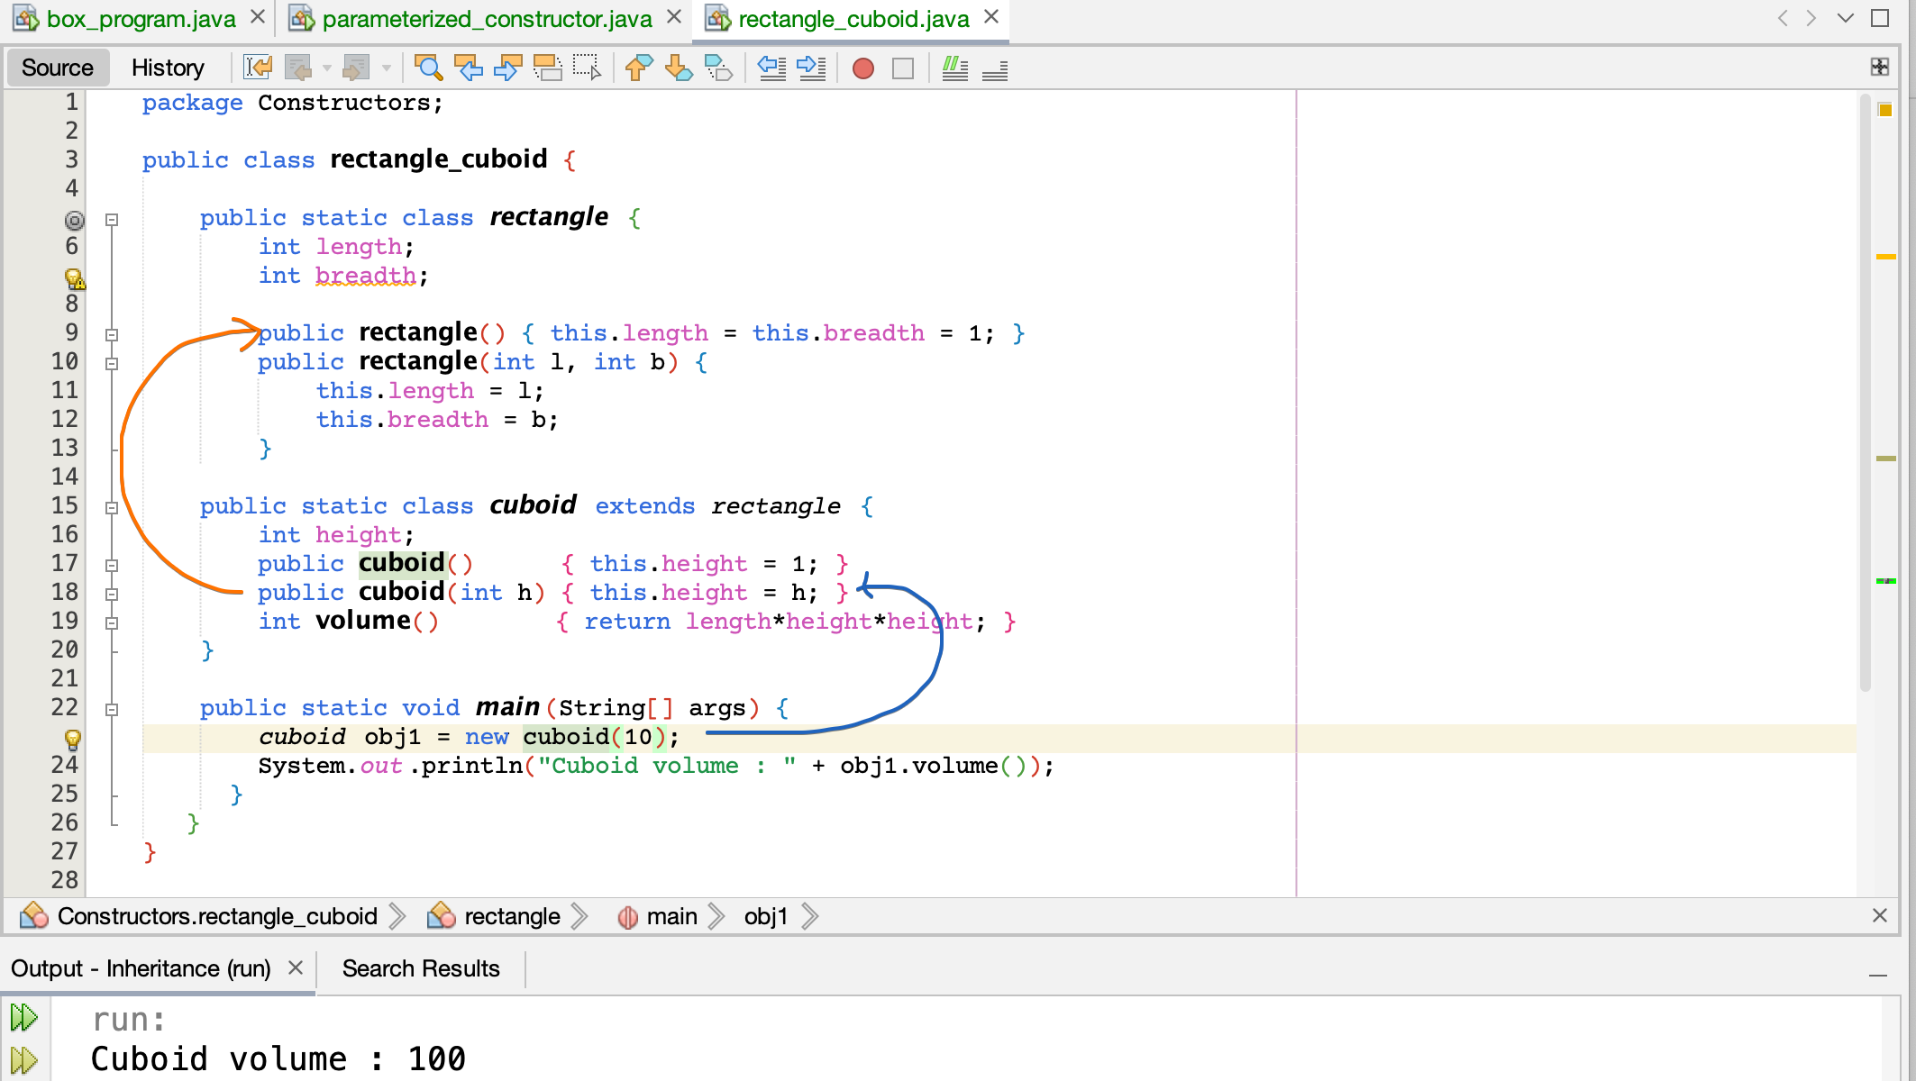

cuboid’s class 🡪 parameterized constructor

rectangle class 🡪 default constructor

What must be done in-order to activate Parent class (rectangle class’s)  
parameterized constructor ??

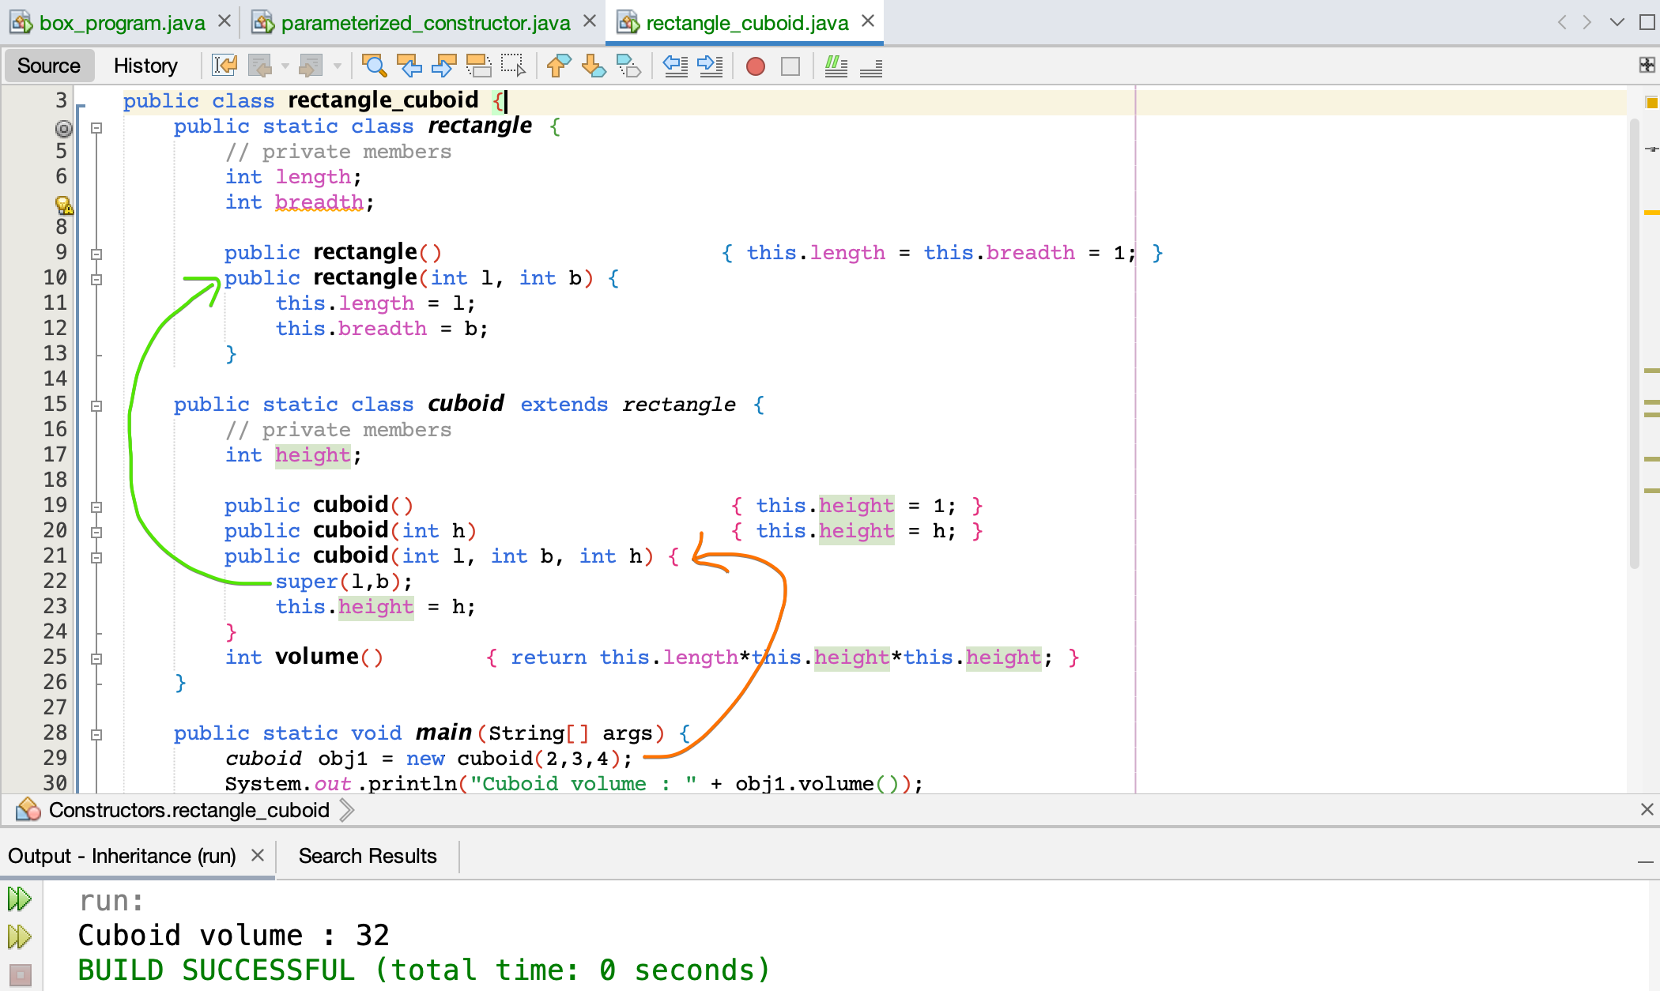

# **this vs super**

this 🡪 reference to the current object

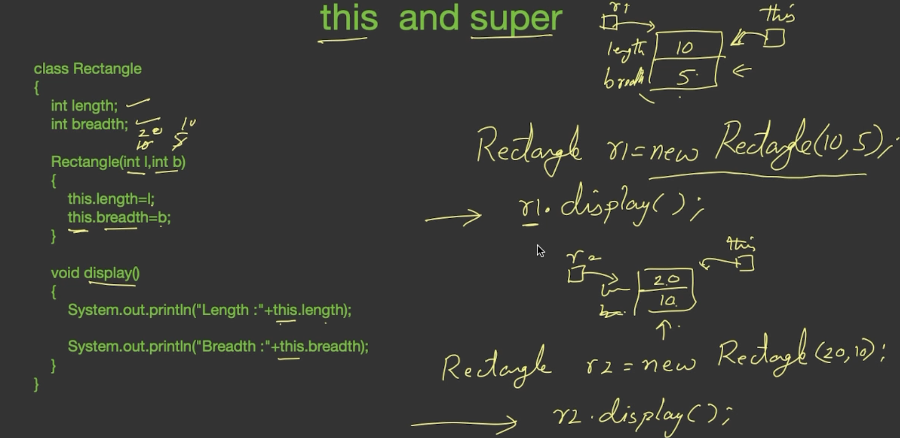

When r1.display() is called, in this.length **this** represents r1.

When r2.display() is called, in this.length **this** represents r2.

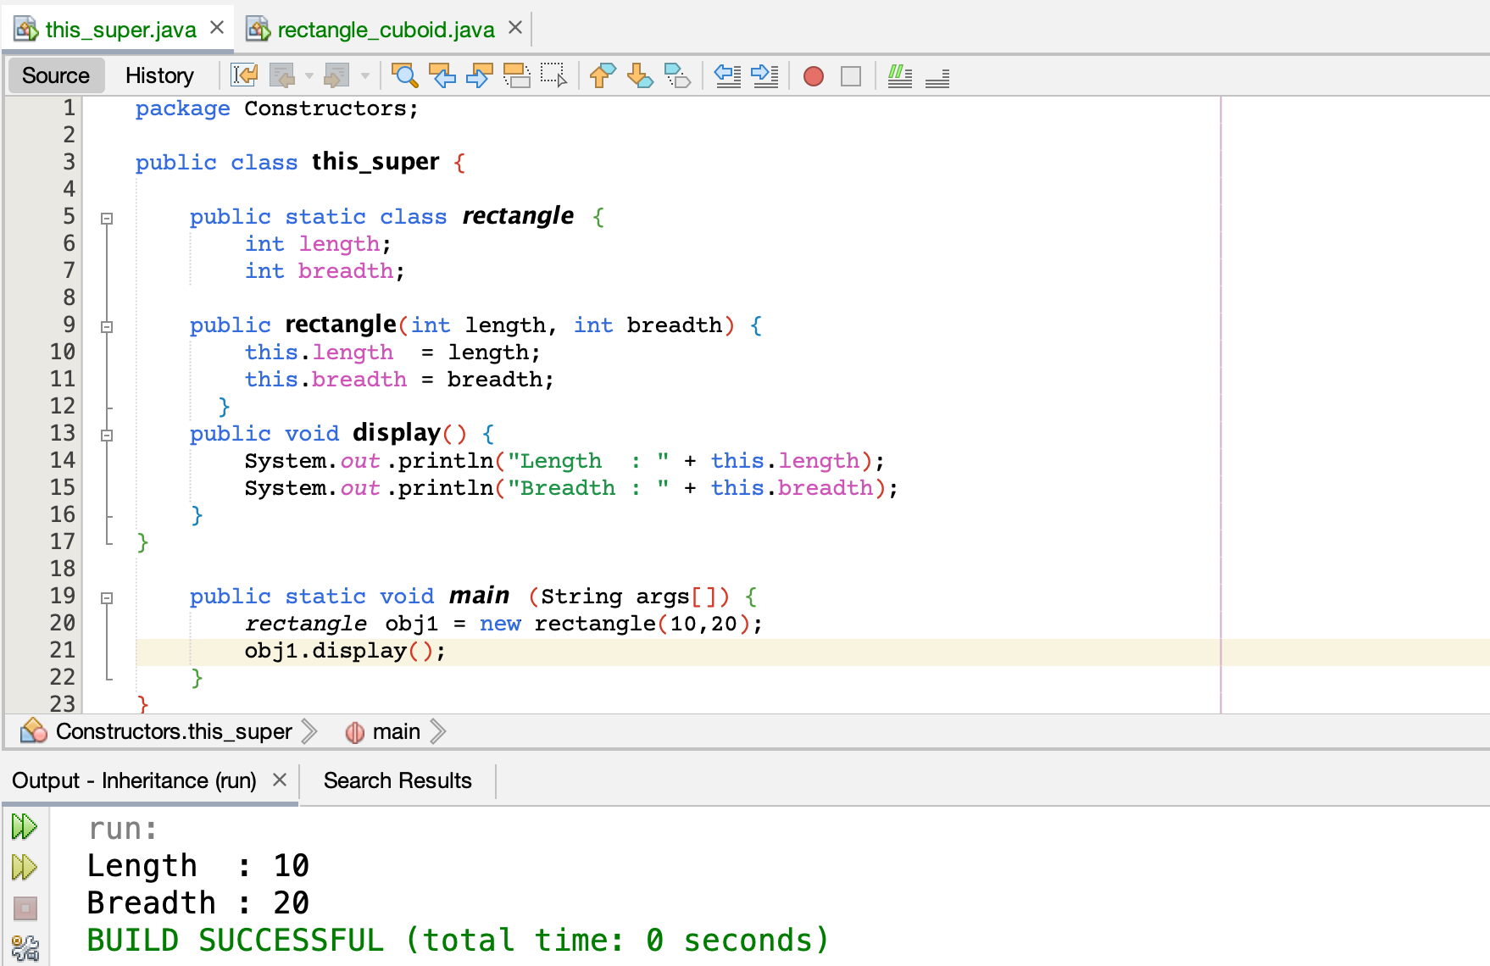

super 🡪 reference to the super class

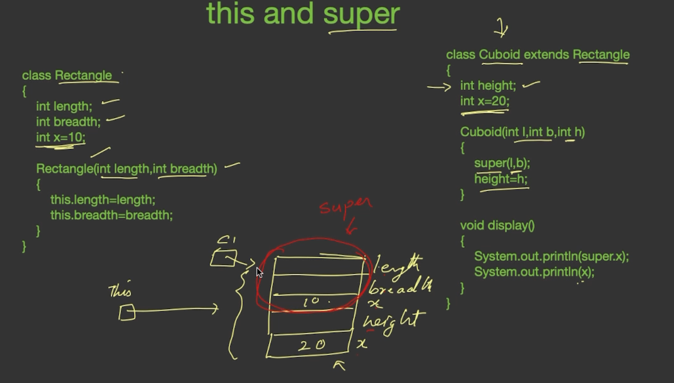

Entire c1 object can be accessed via this.

But these red region can be accessed via super.

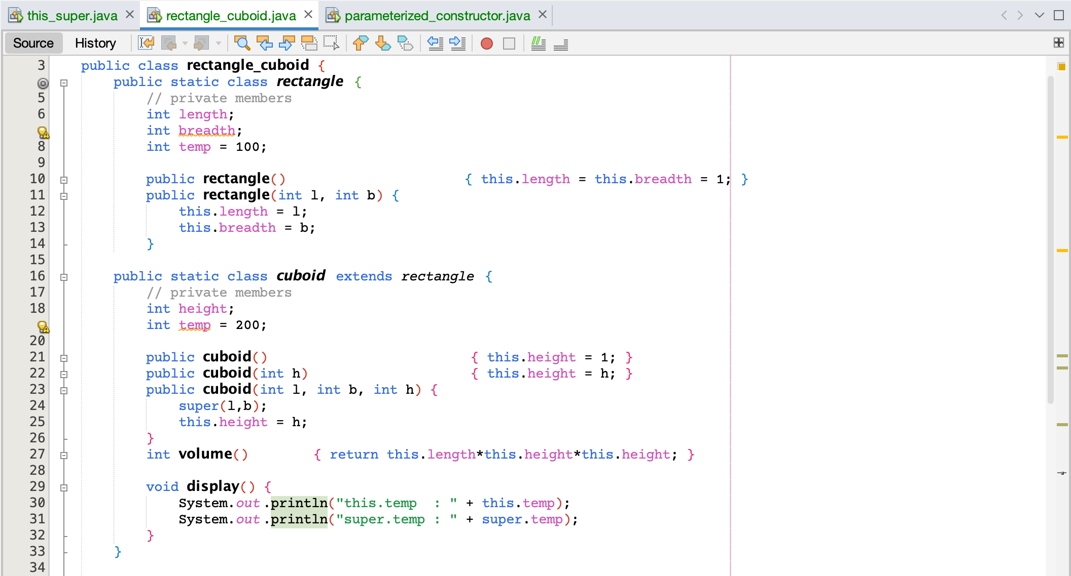  
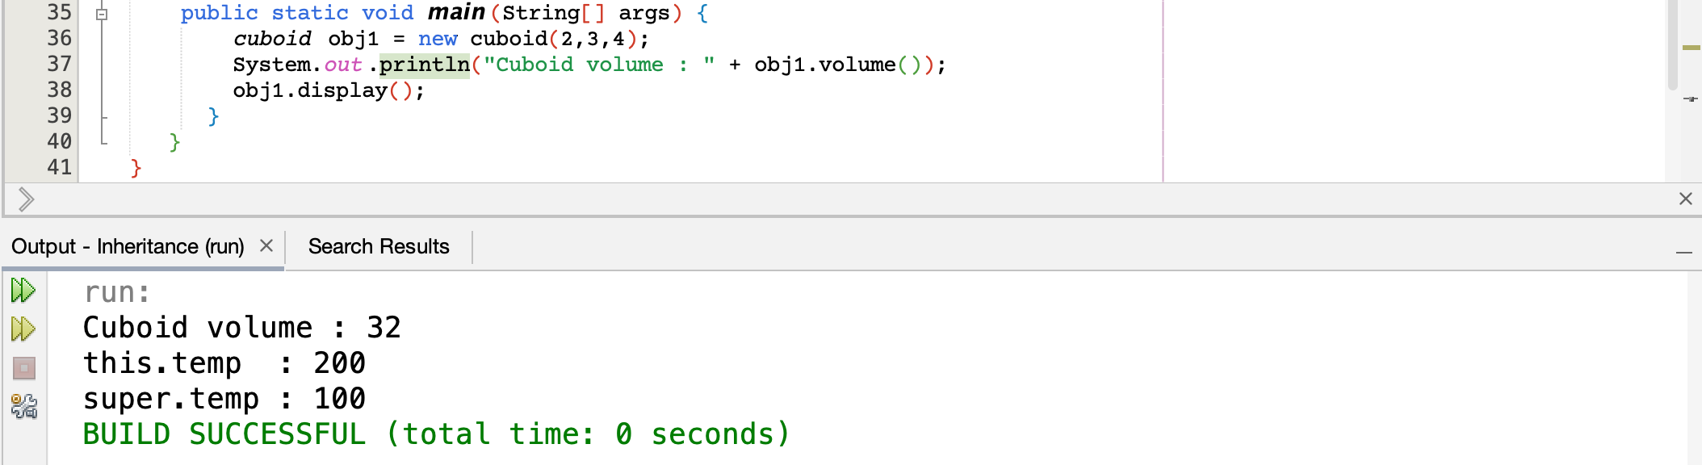

super.temp 🡪 100

obj1.temp 🡪 this.temp 🡪 200

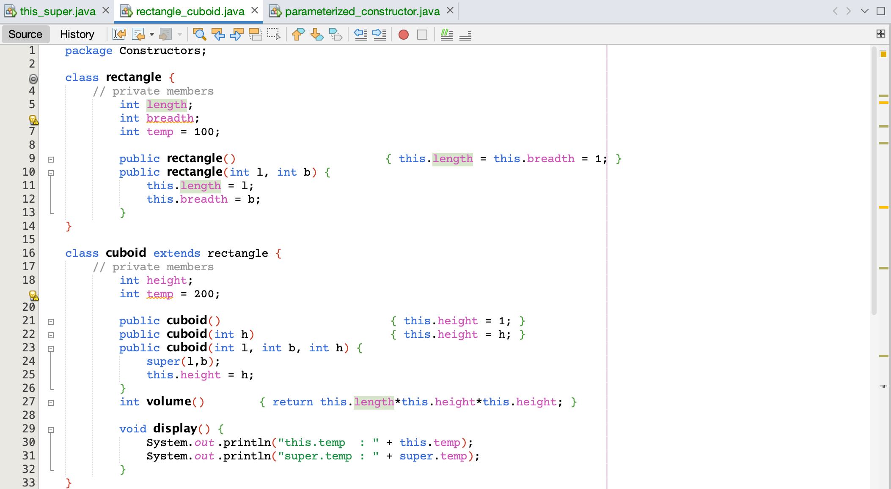  
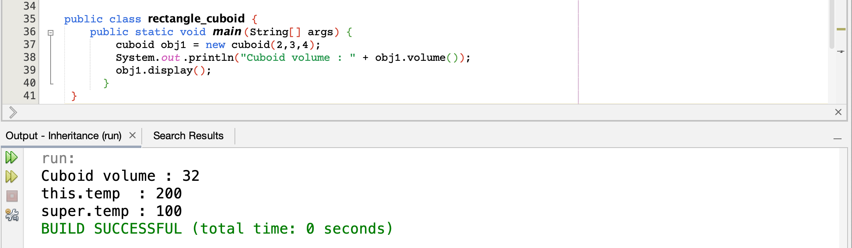

# **Method Over-riding**

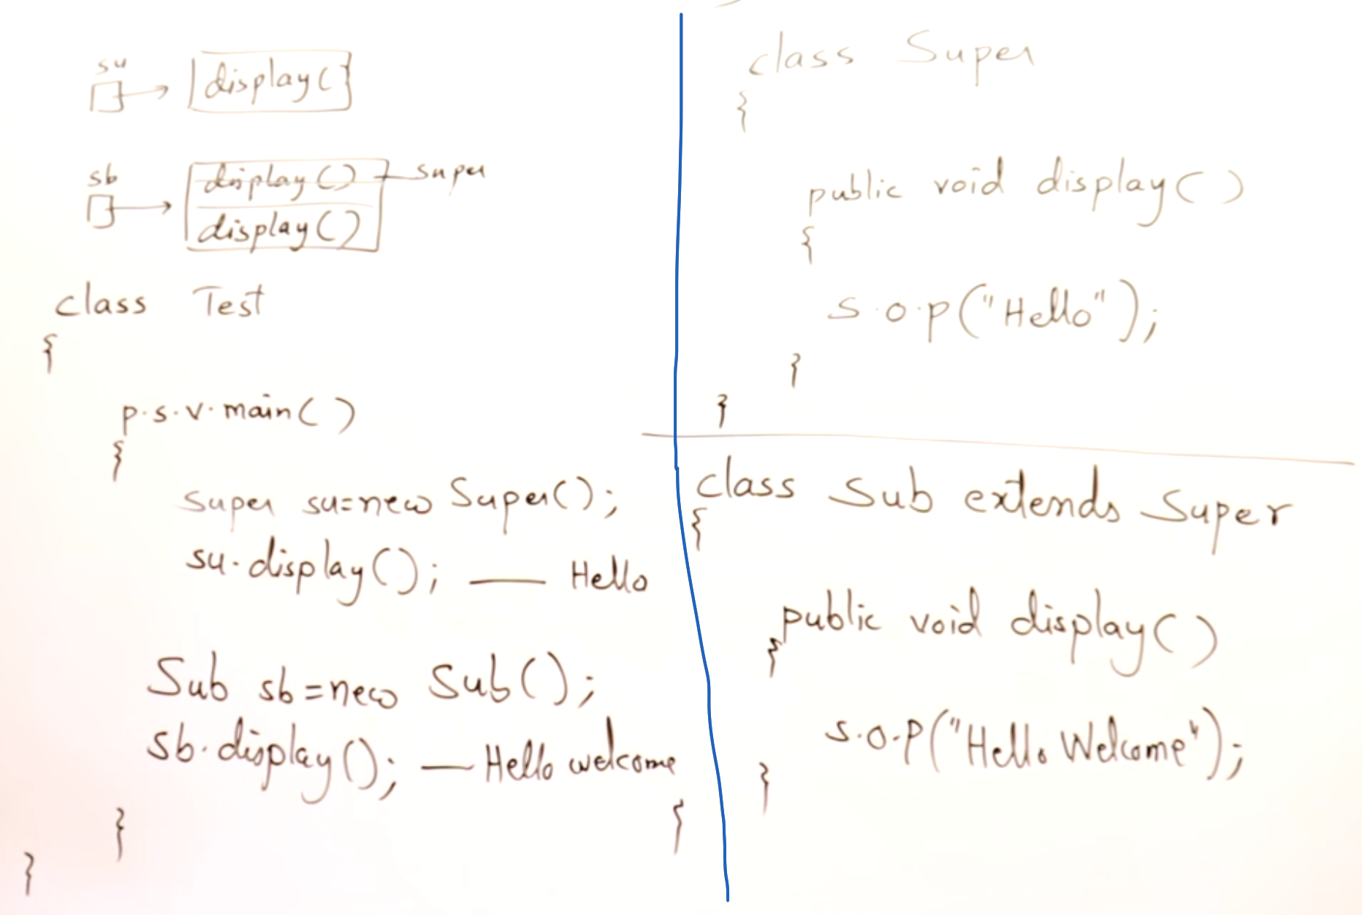

Method calling will depend upon objects and not upon references.  
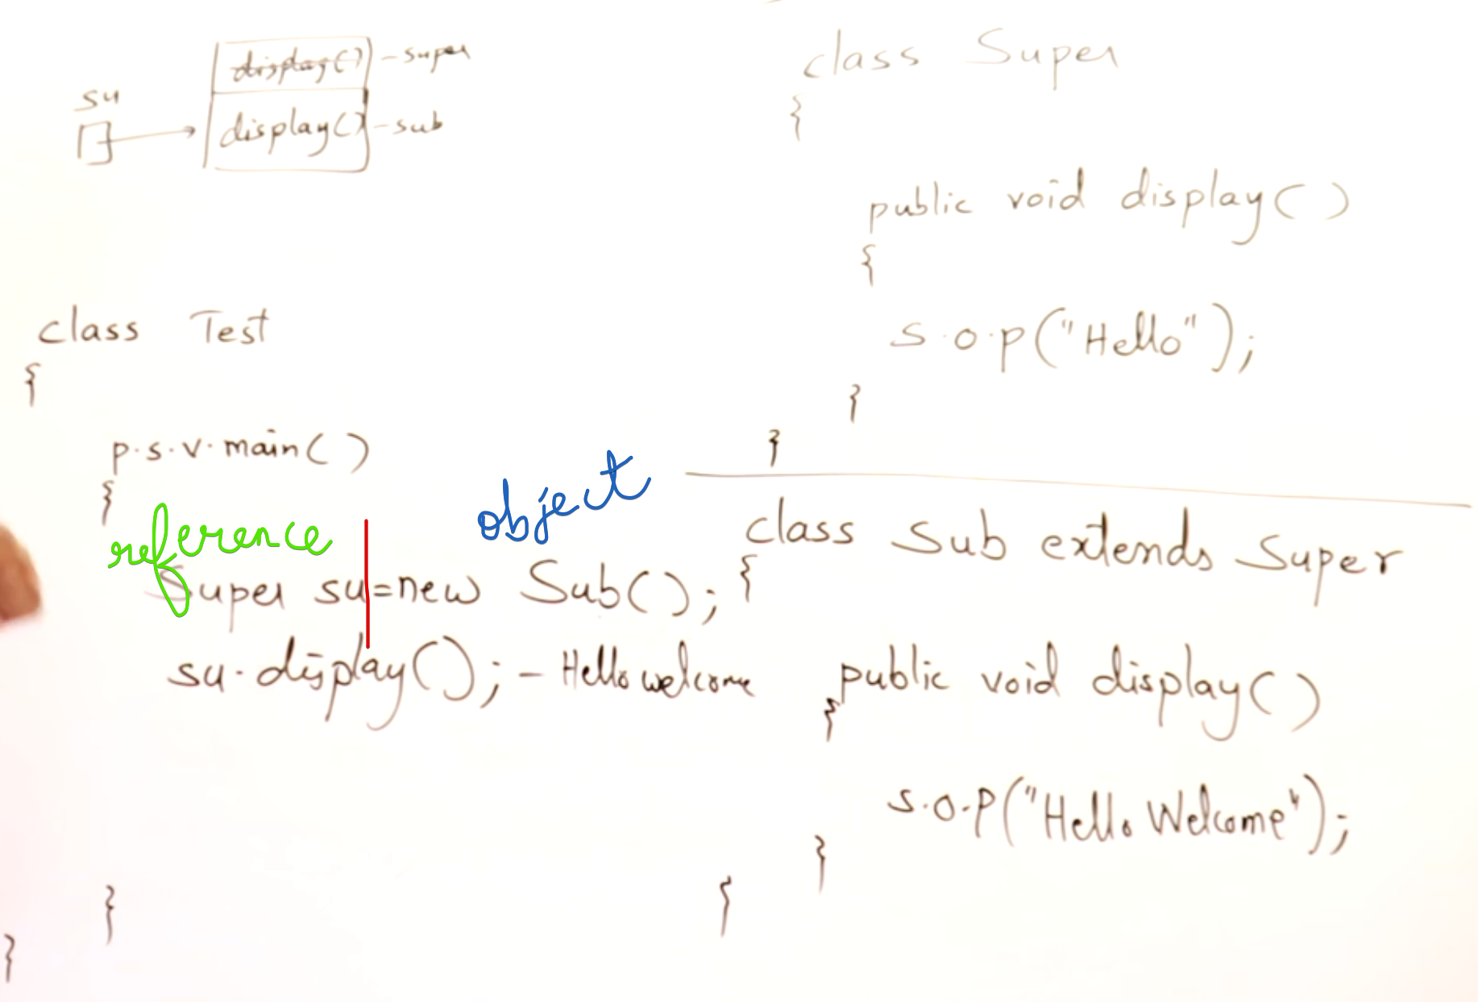

A super class reference holding the method of sub-class and over-rided method is called,   
then the method of the object is called.

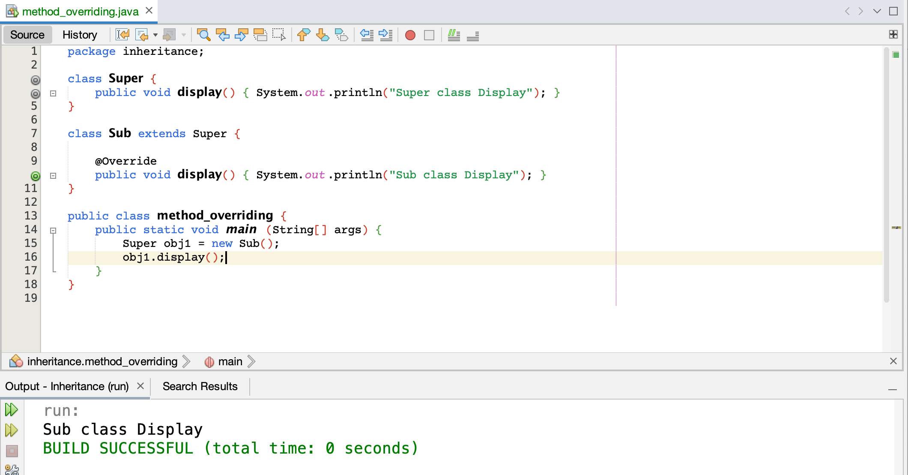

A super class reference holding the method of sub-class and over-rided method is called,   
then the method of the object is called.

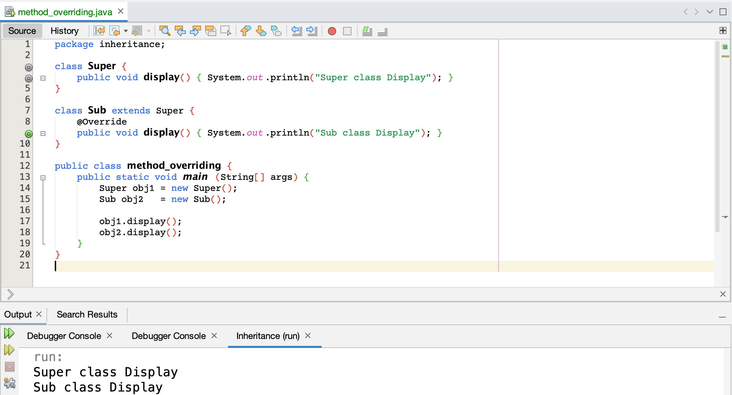

## **Eg:1**

Refer tv_and_smarttv.java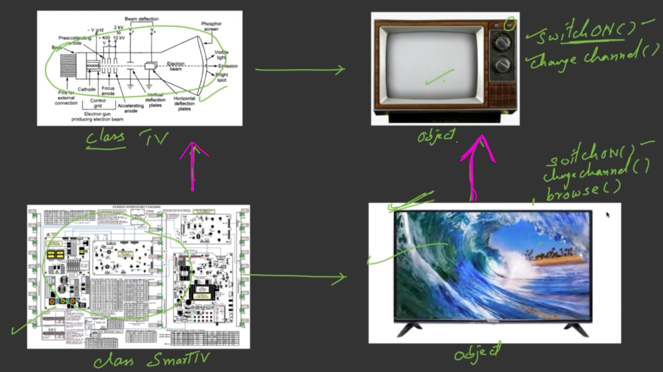

In class TV, switchON() and change_channel() are done using buttons.  
In class SmartTV, switchON() and change_channel() are done using remote.

browse() is the additional function in class SmartTV.

switchON() and change_channel() are over-rided.

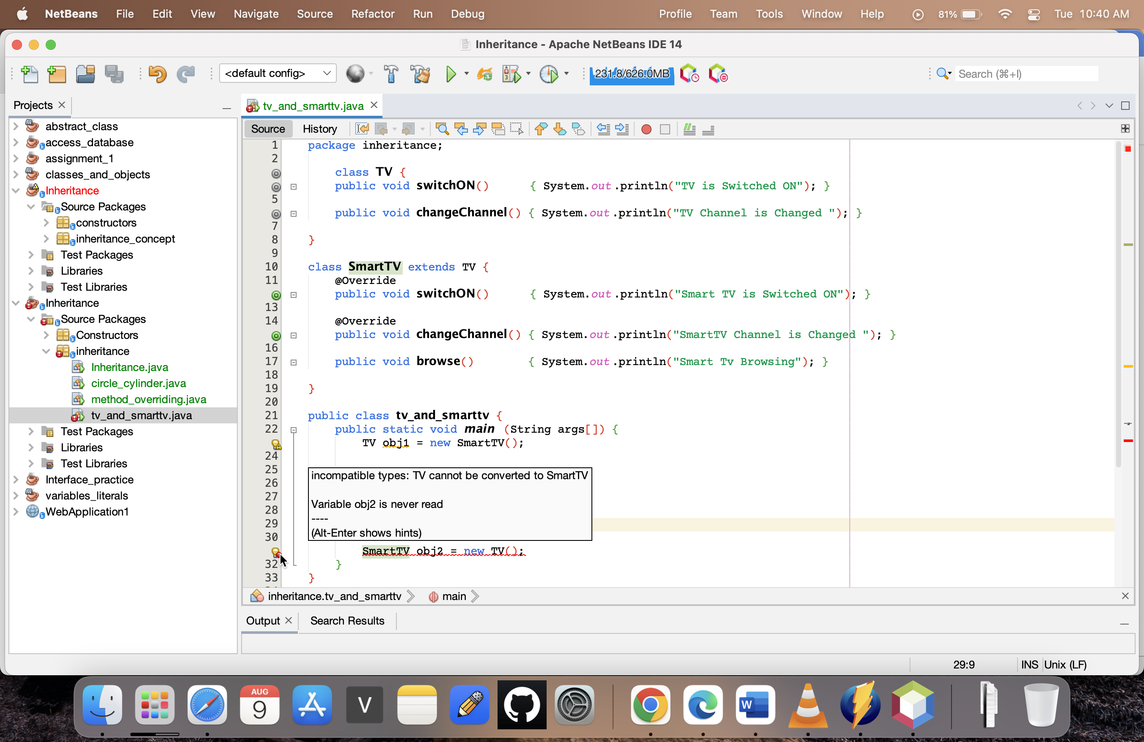

Look at Smart TV, will say that this is TV (TV obj1 = new SmartTV())

Look at TV, will not say that this is SmartTV (SmartTV obj1 = new TV())

So we can take a reference of Super class and have the object of Sub class.

But taking a reference of Sub class and have the object of Super class 🡪 Not Possible

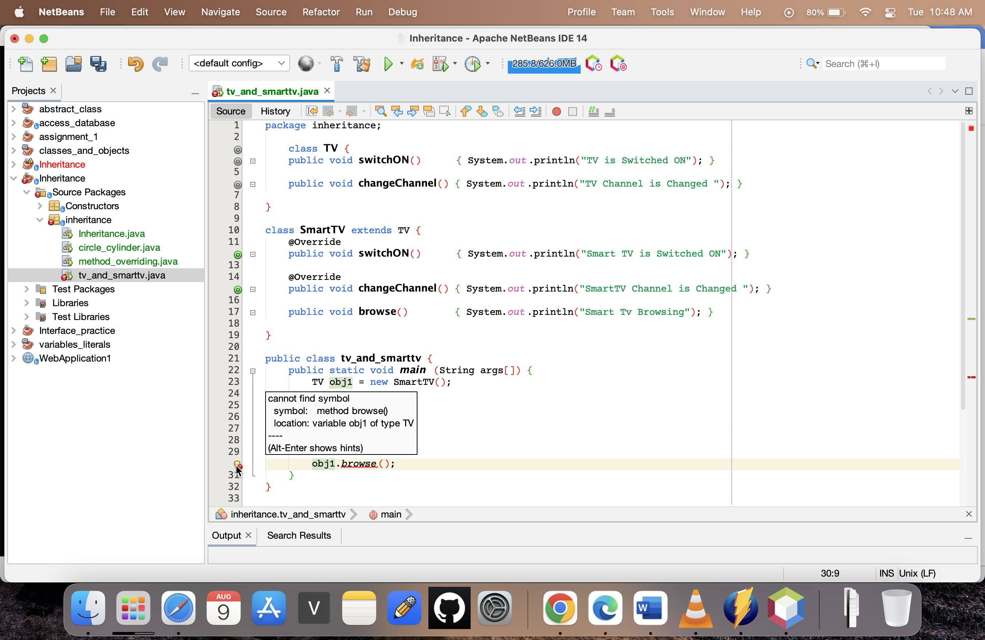

**TV reference with Smart TV object 🡪 access only Normal TV features**

I am having normal CRT TV. So after some times I bought Smart TV.   
But still we will try to use as a normal CRT TV.

Even-though there are many additional functions in Smart TV, initially we will try to use as a normal TV [don’t know browse()]

**Smart TV reference with TV object 🡪 access both Normal TV and SmartTV features**

But slowly will try to change.

## **Eg:2**

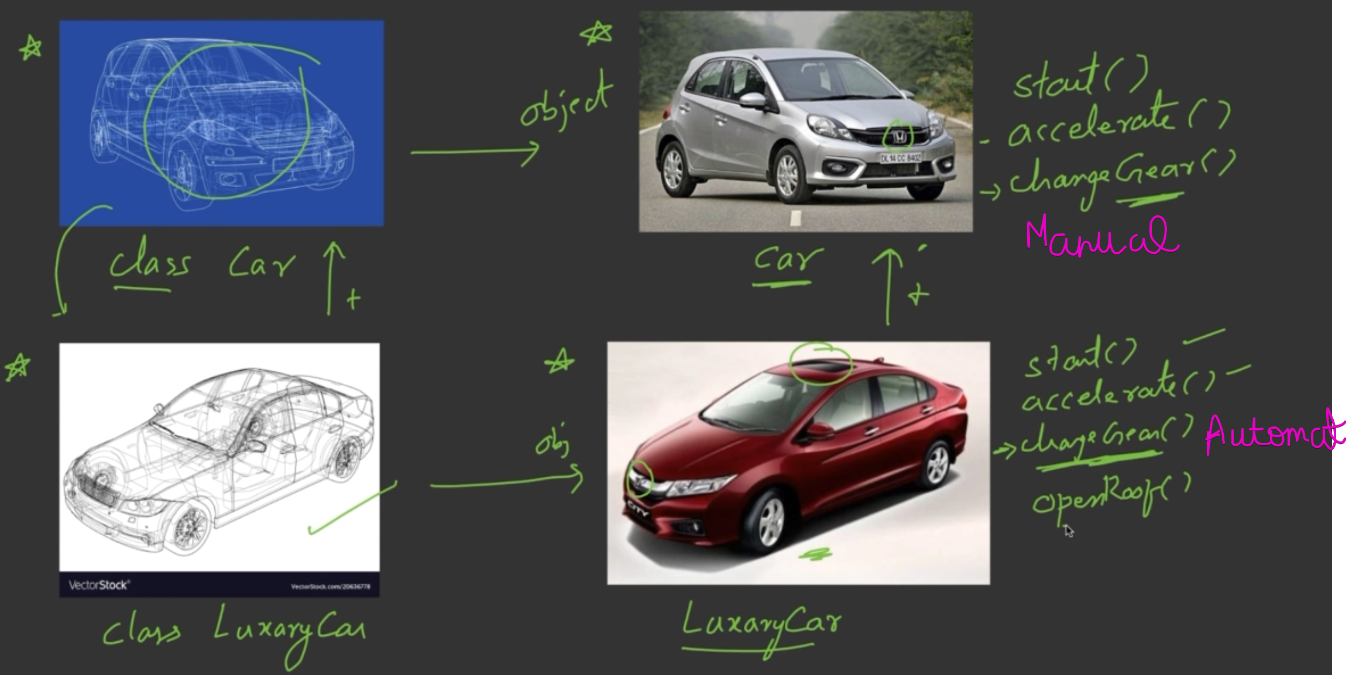

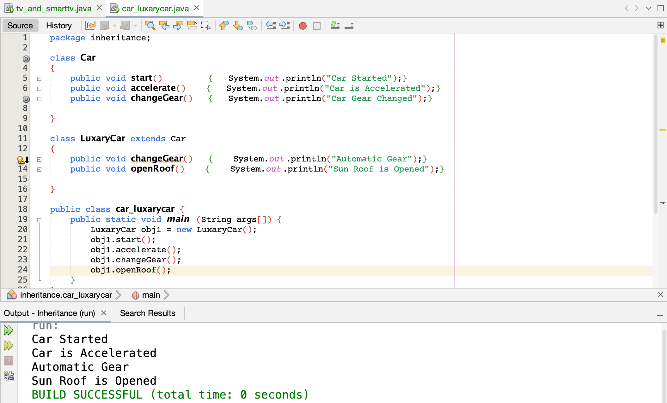

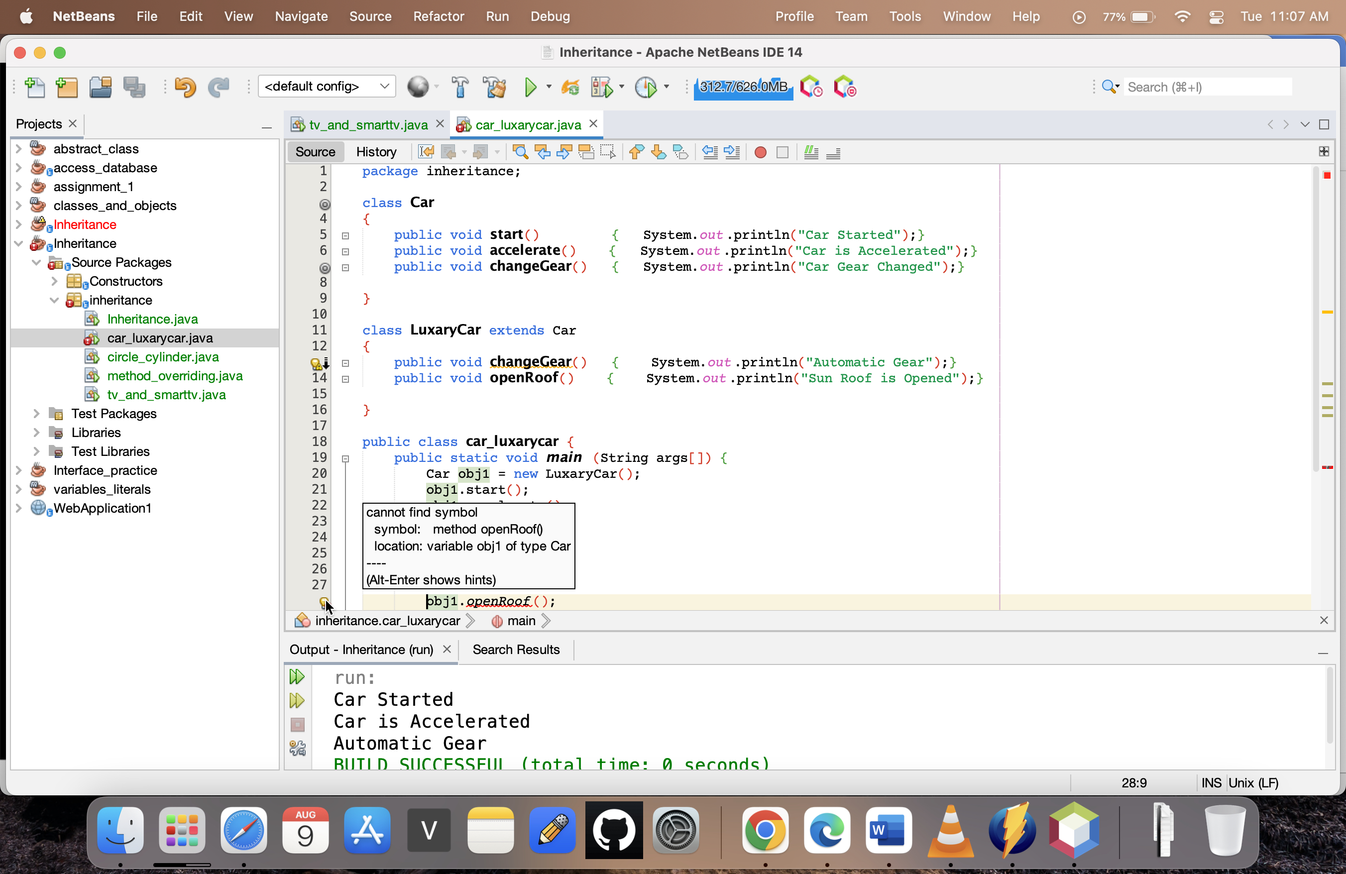

A super class reference holding the method of sub-class and over-rided method is called,   
then the method of the object is called.

So obj1.openRoof() can’t be called.

# **Dynamic Method Dispatch**

Dynamic 🡪 During run time  
Method 🡪 functions

Dispatch 🡪 Calling

This is used to achieve run time polymorphism using method over-riding.

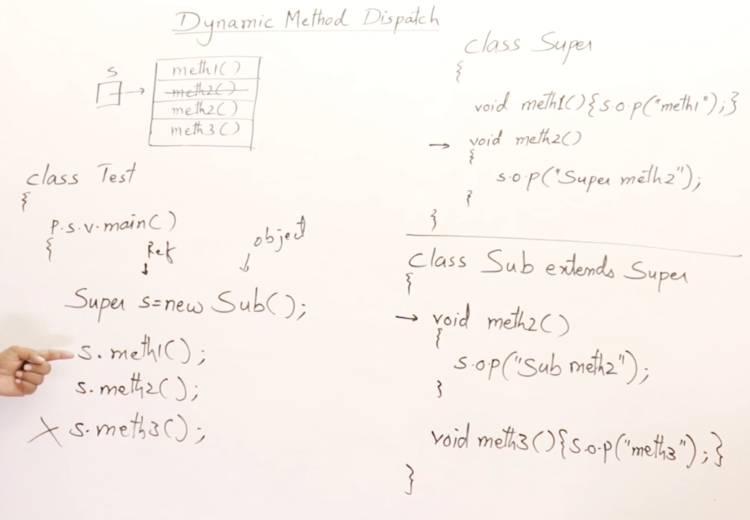

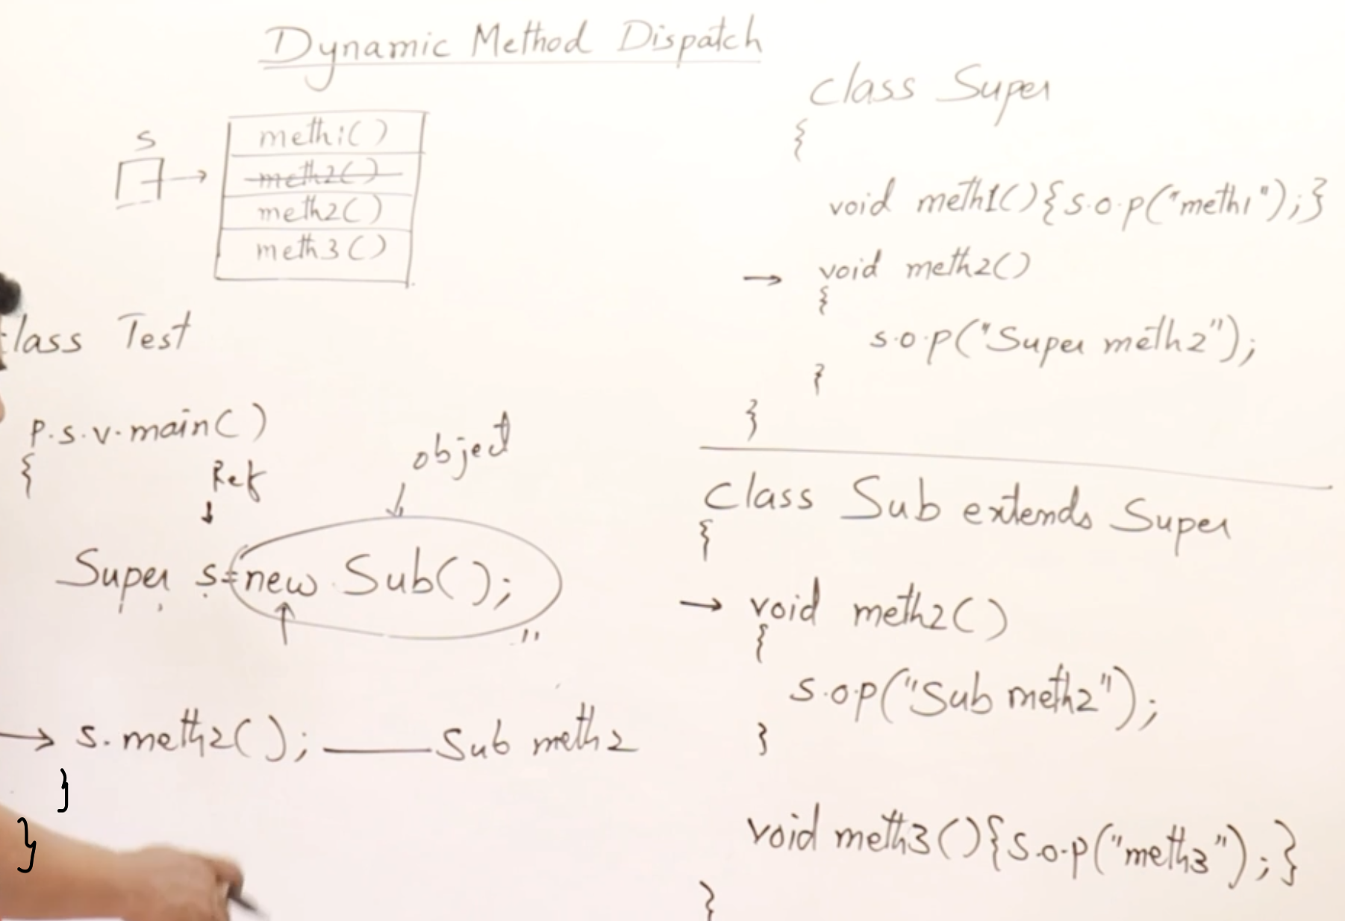

Depending upon the object, that particular method will be called. Program will take decision at the run time.

If you are holding the object of super class, then super class method will be called.

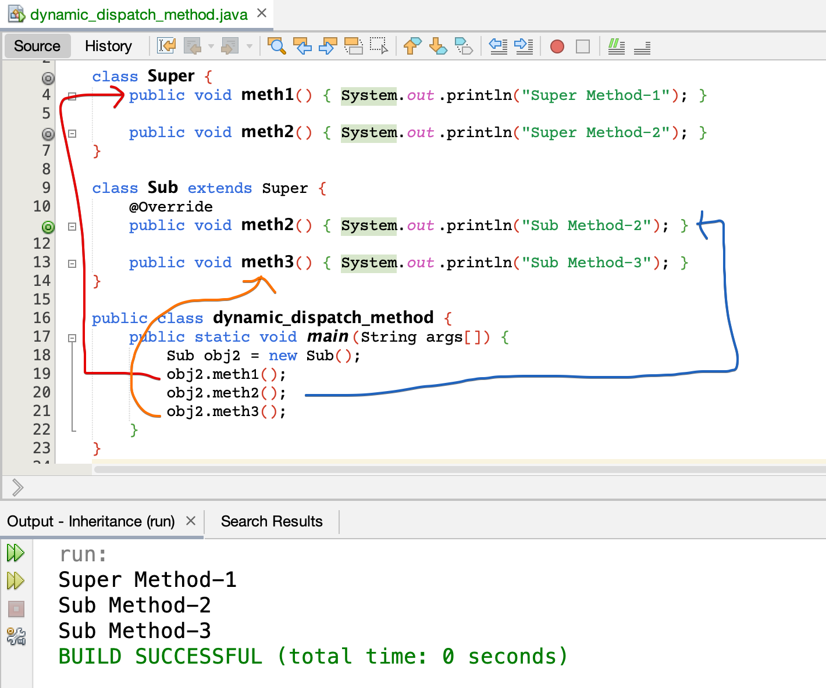

Sub class reference with Sub class object.

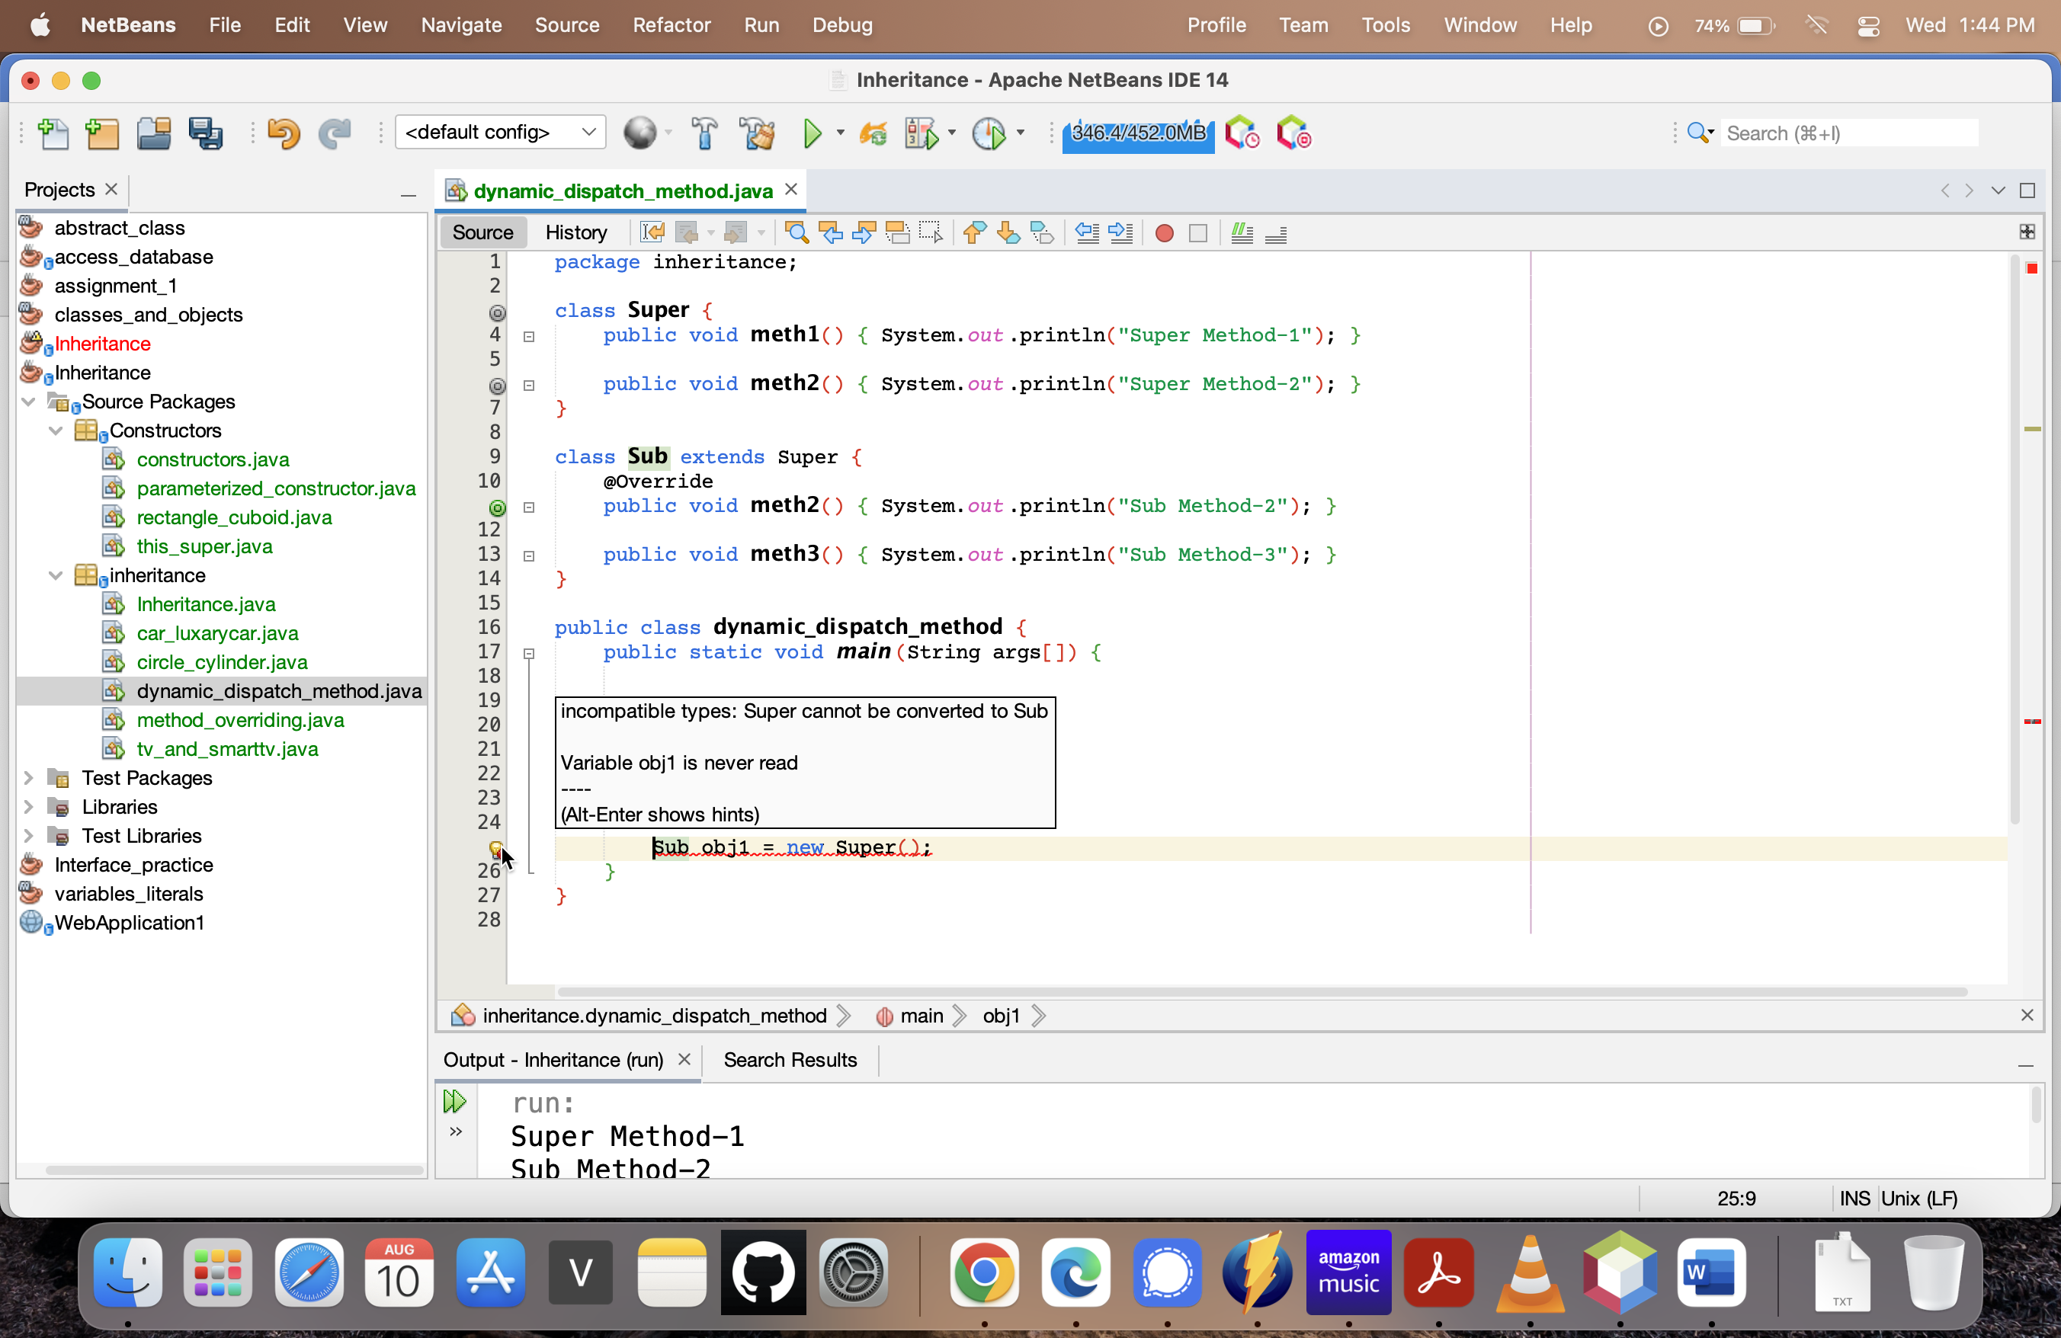

Not at all possible

Sub class reference with Super class object.

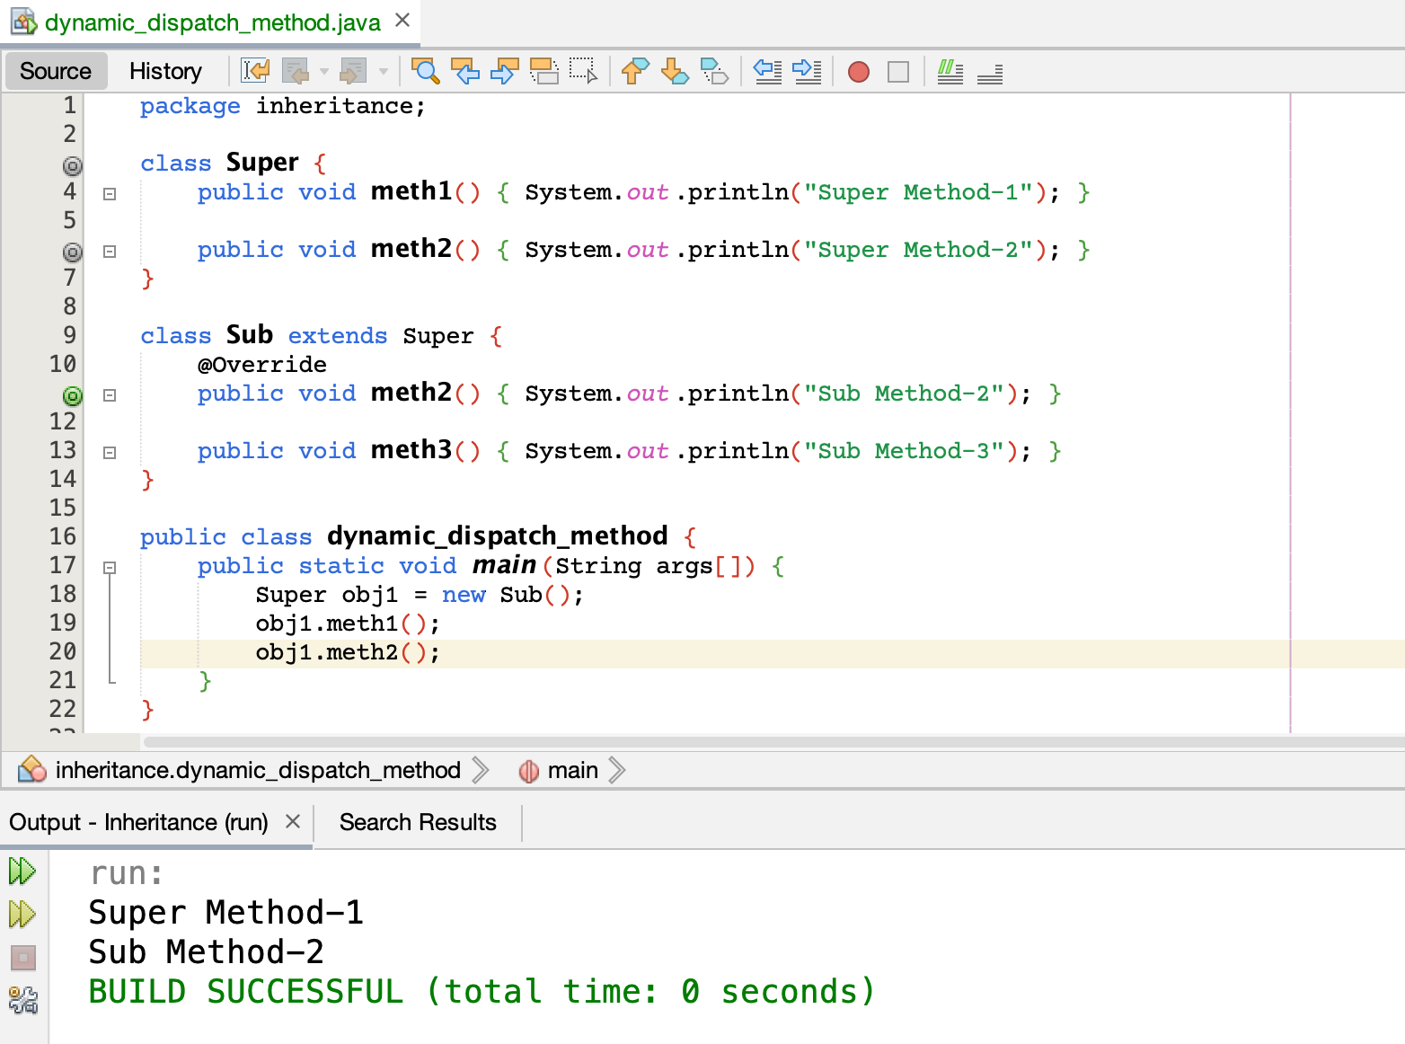

Super class reference with Sub class object.

# **Types of Inheritance**

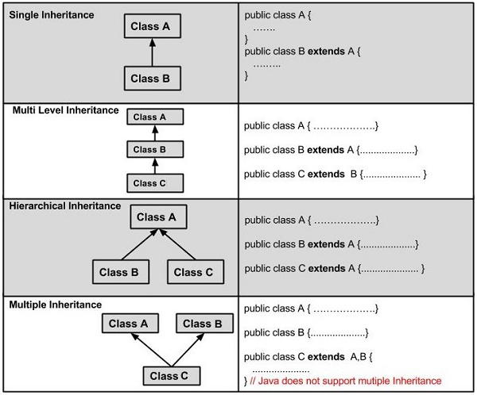

# **Refer BOX program.pdf**

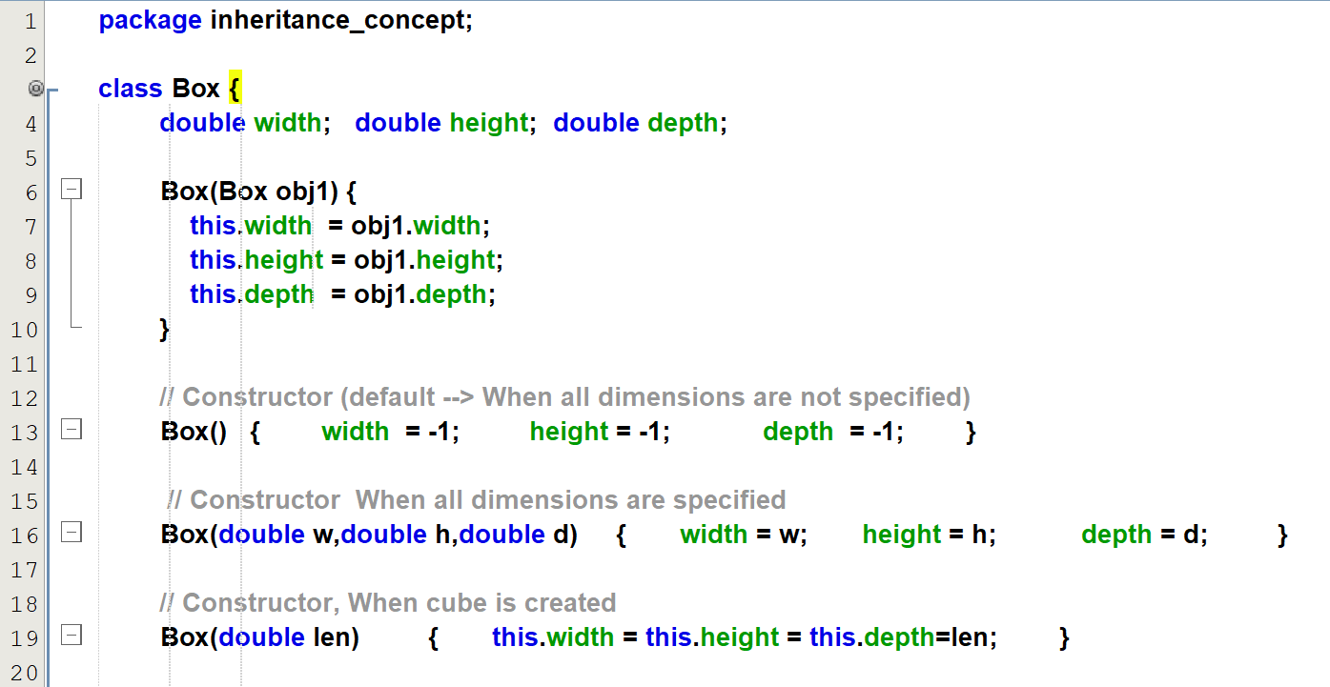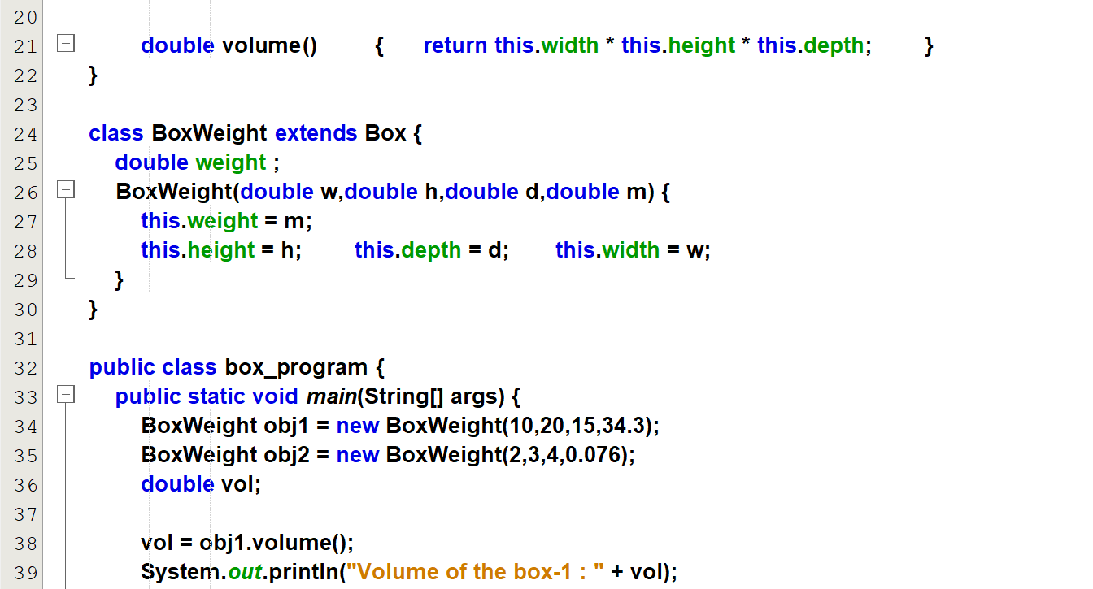  
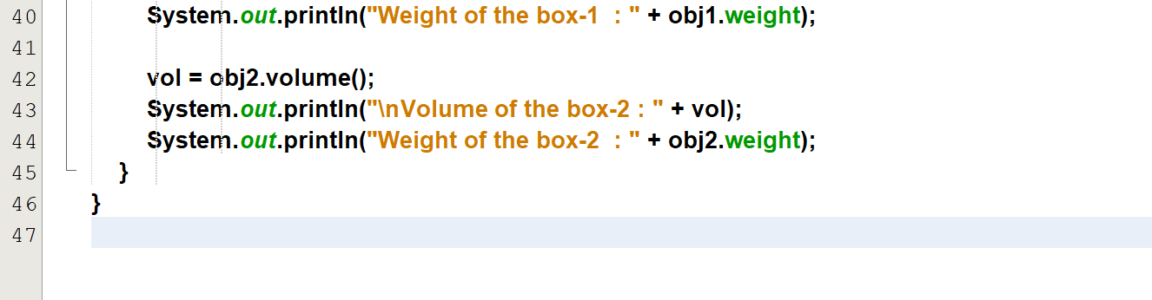

Output  
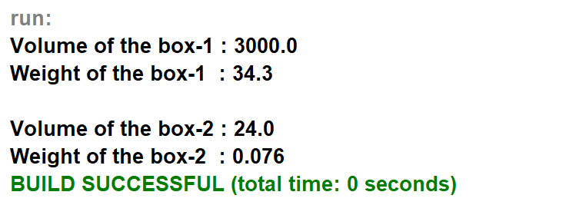

**Refer super_box_program**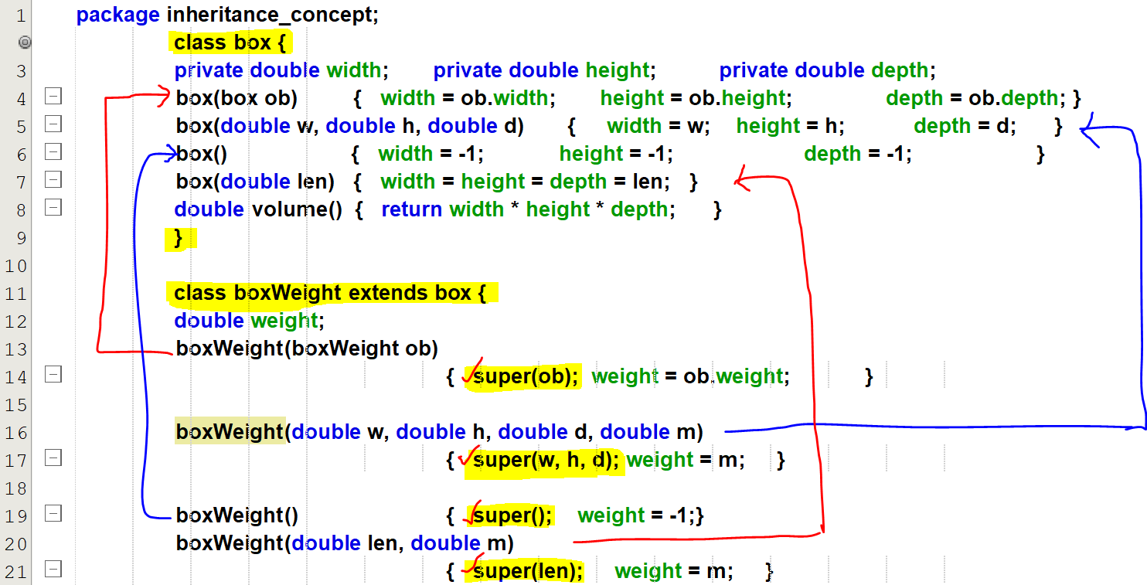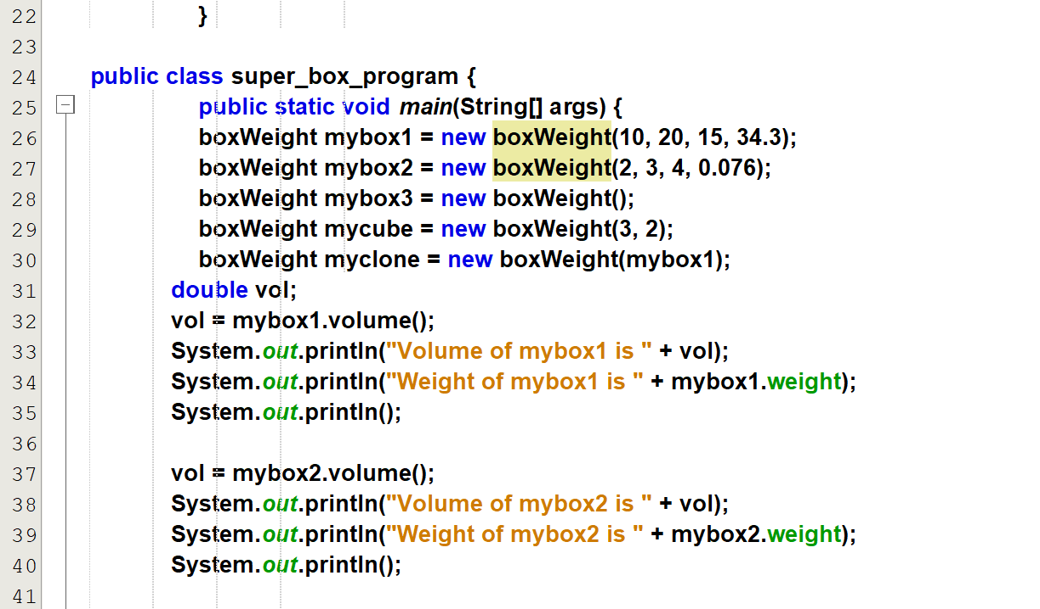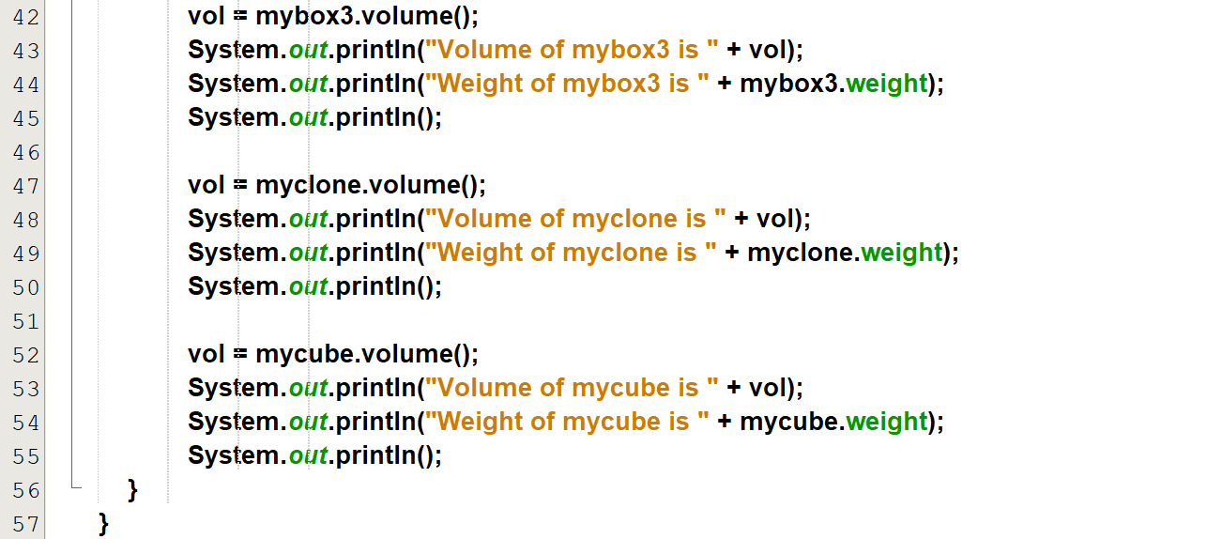

**Output:**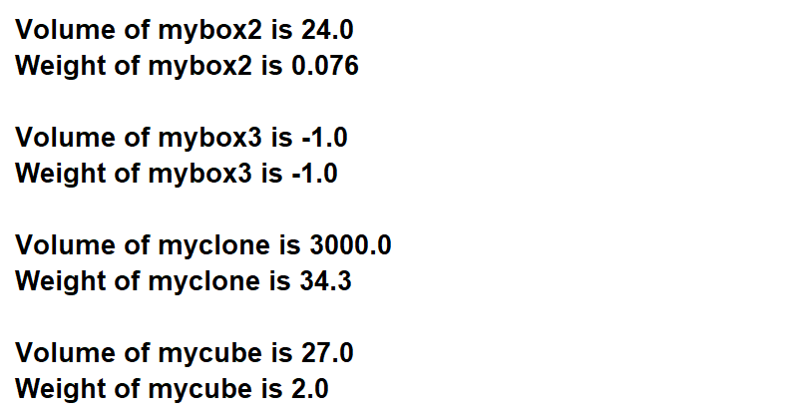

**Refer multi_level_box_program**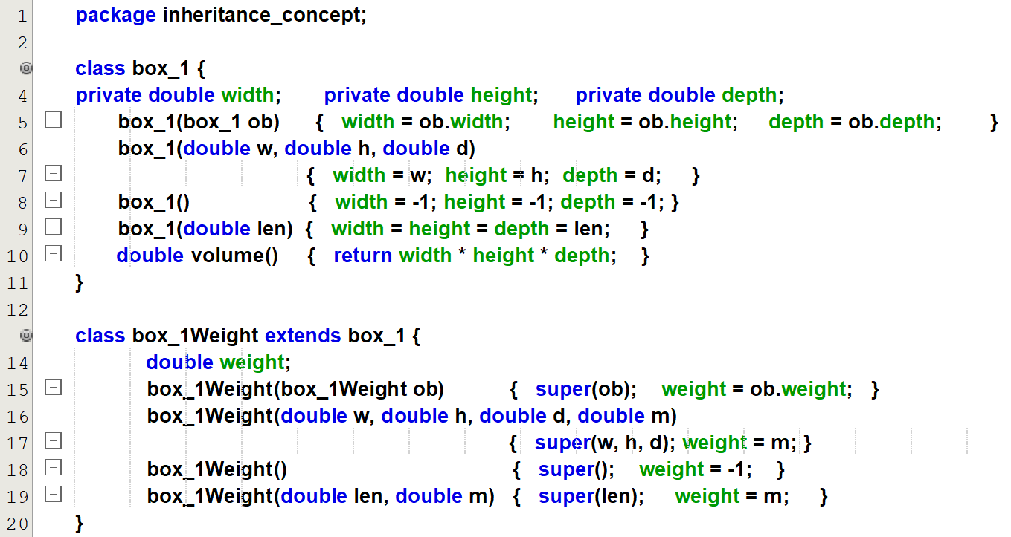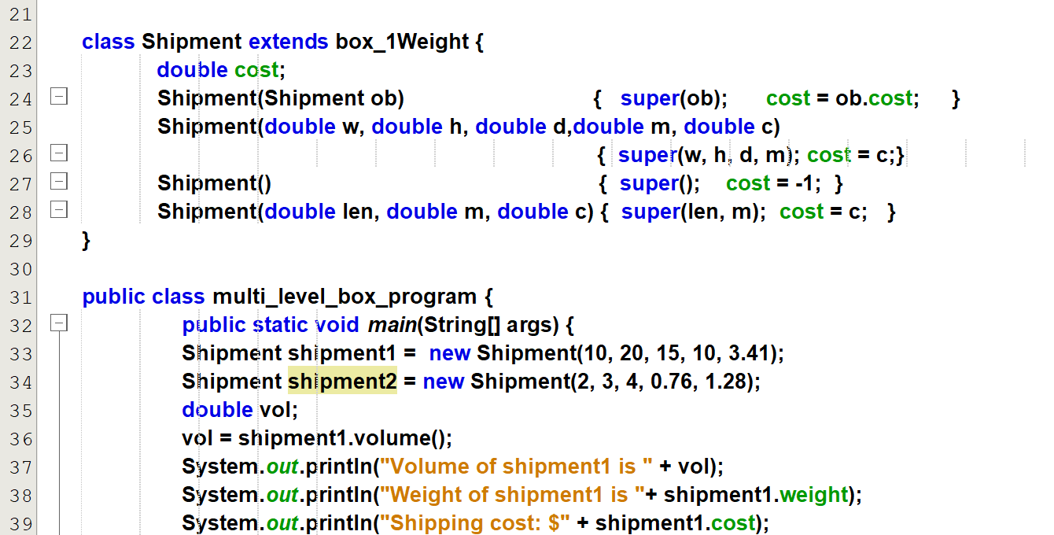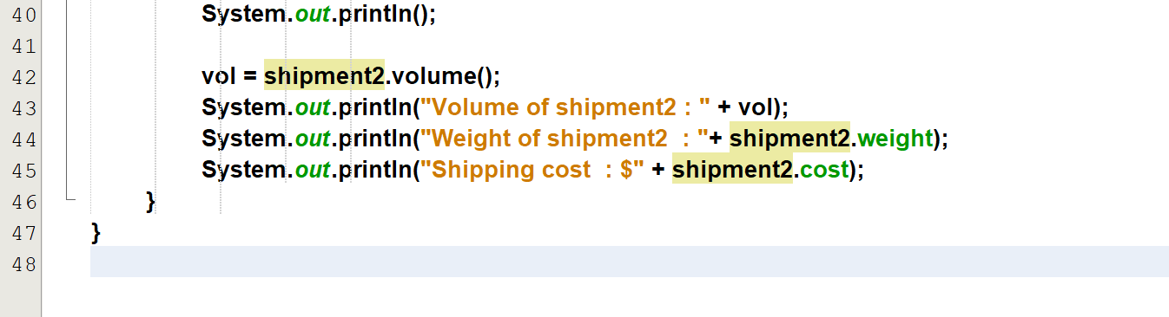

**Output:**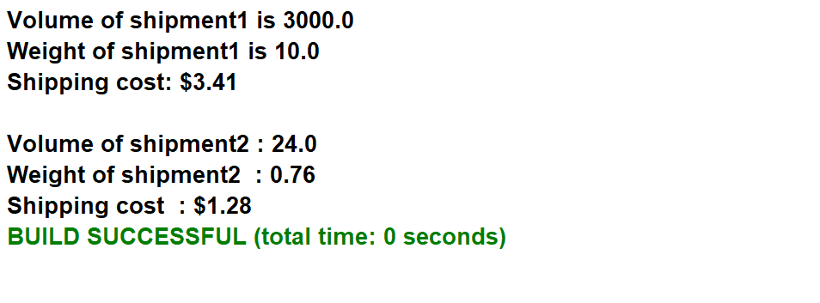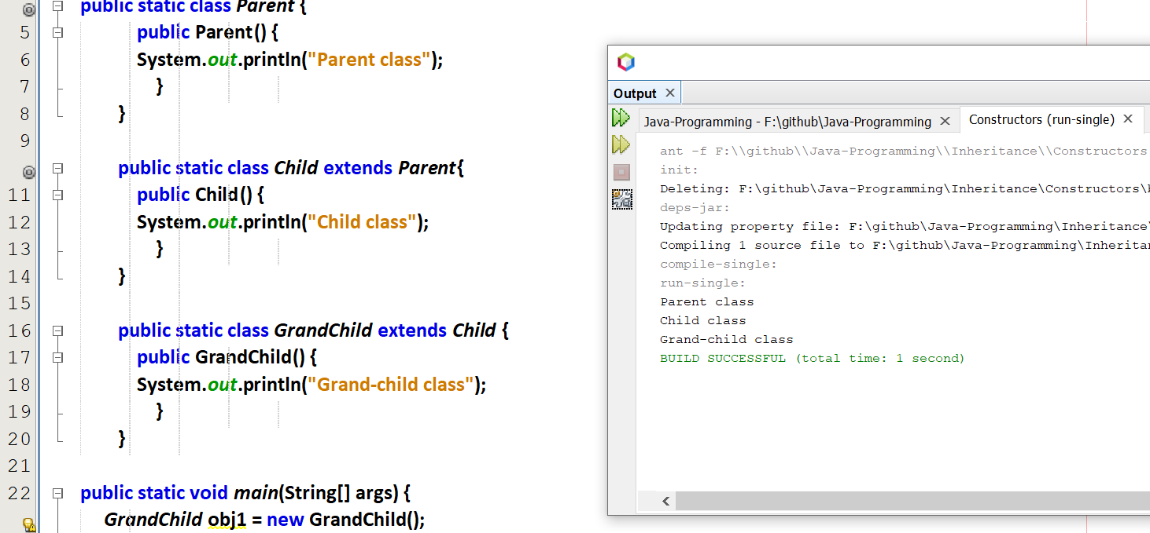

Constructors are created at the creation of object itself.

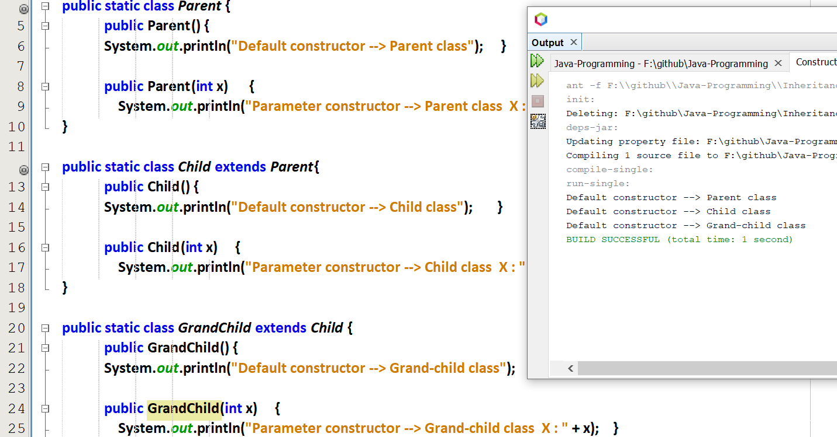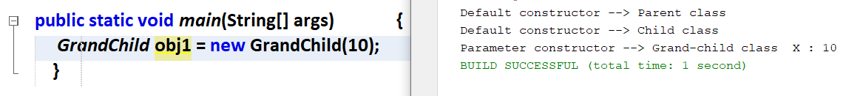

How to pass x to the child and parent class.

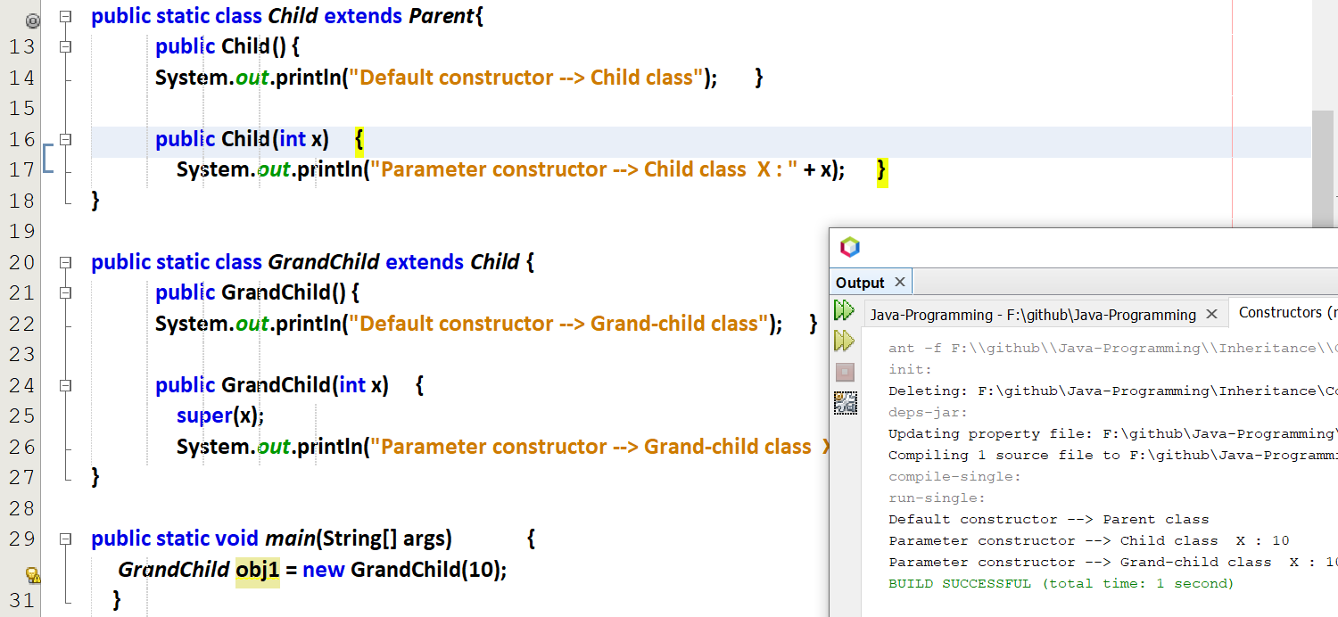  
super() in GrandChild



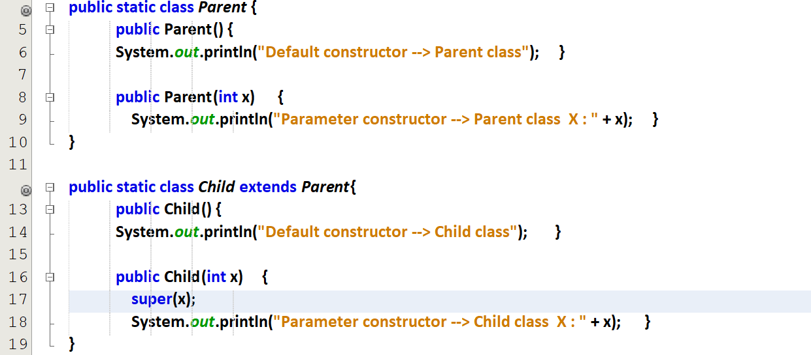  
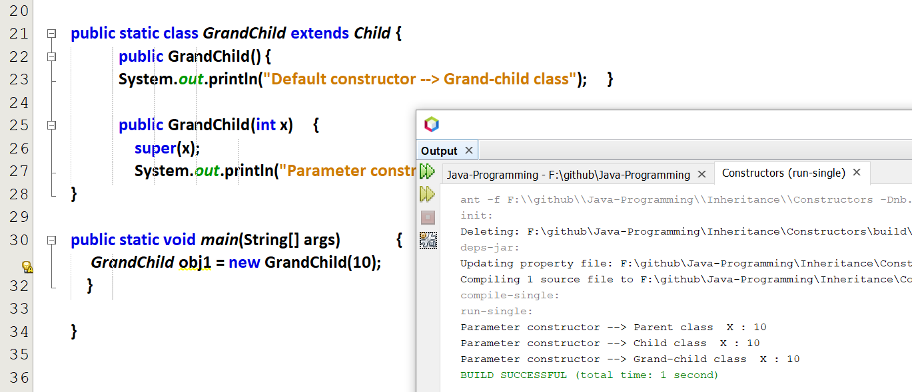



super() in GrandChild() and child()

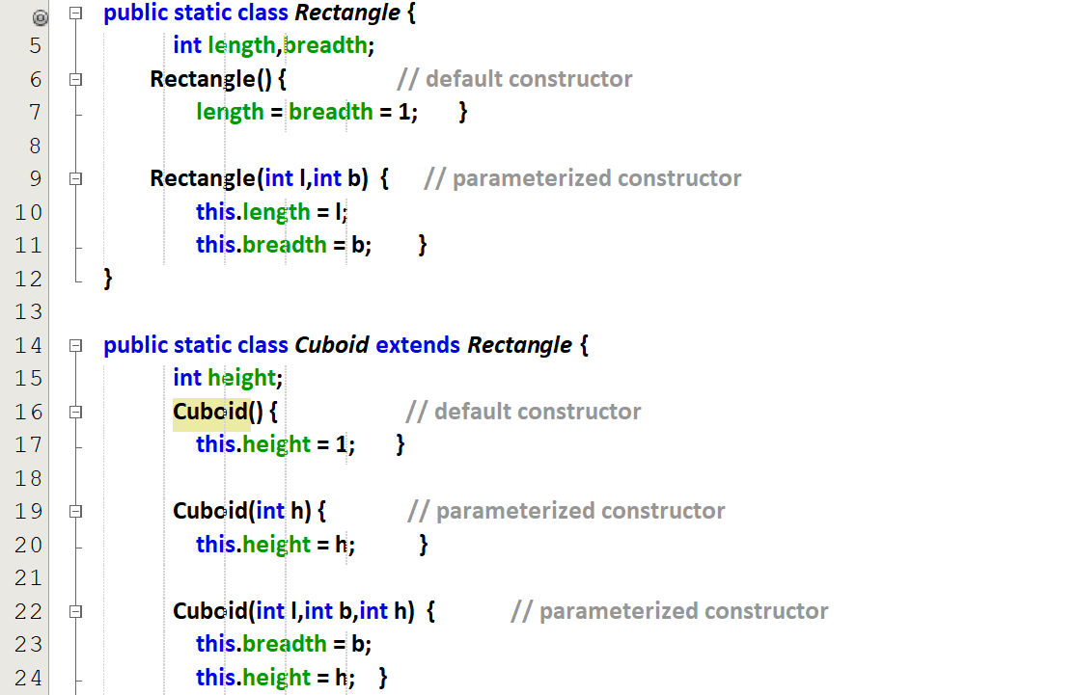  
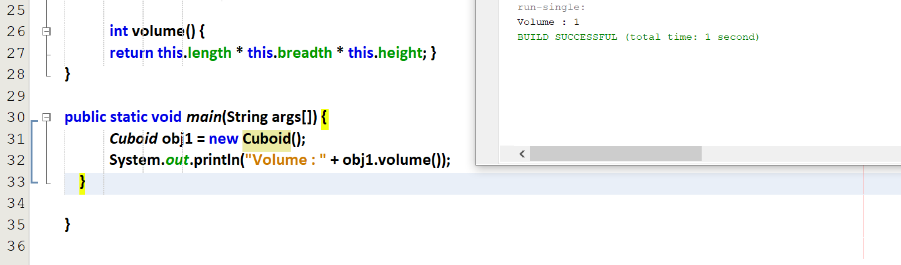

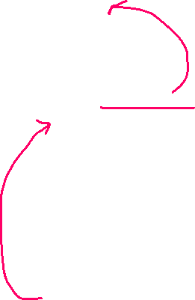

In this length=height=breadth=1, so volume =1

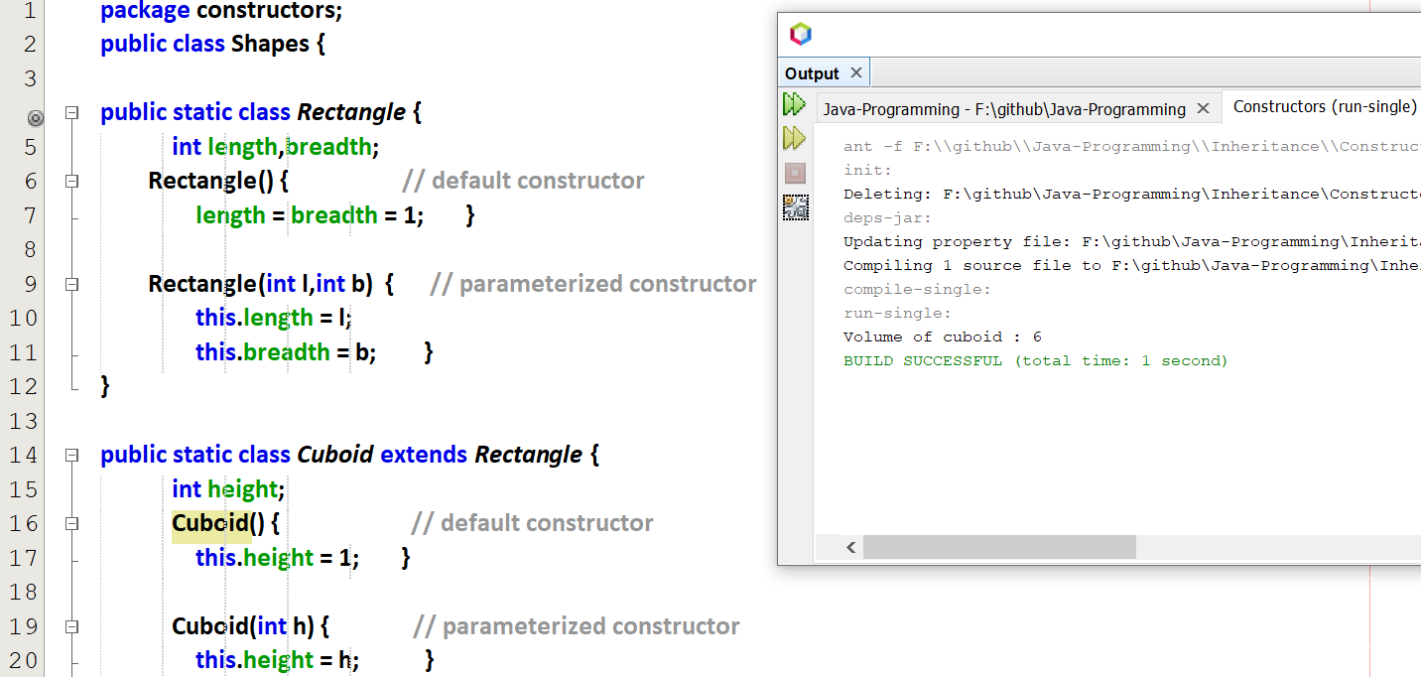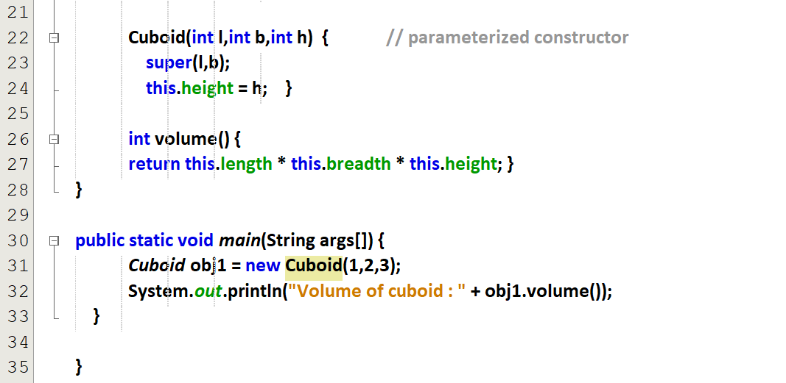



In this length=1 and height=2 and breadth=3 so volume = 6

With abstract class reference we can make the concrete class object.

# **References**

[Generalization and Specialization in Java - GeeksforGeeks](https://www.geeksforgeeks.org/generalization-and-specialization-in-java/)